St. Peter’s Herald

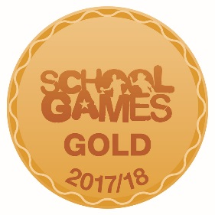

Pupil Voice from Autumn Term 2018

Here are some of the children’s highlights from this term…
I enjoy working with my friends to do Math’s problems. Doing tricky timestables like ‘8X7’ have really challenged me.
I know now that the answer is 56.
Reuben 2F

I liked learning about number bonds to 100.
George 1R
I have enjoyed learning amazing things like column subtraction. I thought it was tricky at first, but now it’s easy. Isabel 2F

I liked spelling tests each week.
Charlie 1R

We like dressing up and doing Christmas activities.
Mia, Oliver & Sam 1R
I liked spelling tests every week.
Charlie 1R

I like all of the Maths we have done.
Orlaith 1R
I like writing very neatly in English.
Hattie 1R

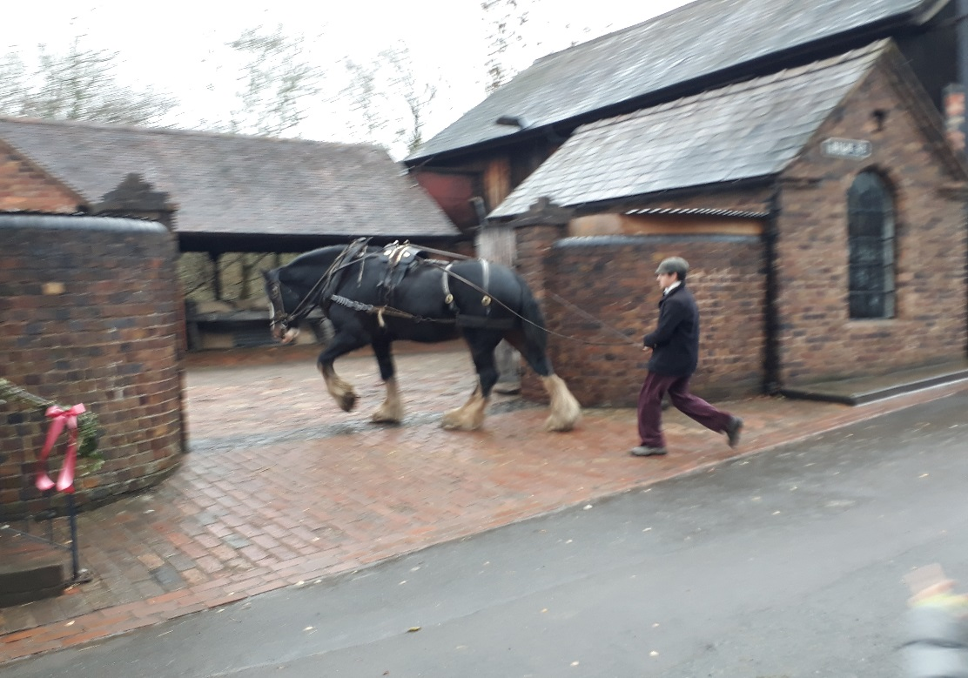
On Wednesday 18th November 2018, Year 6 went to Blist Hill in Telford. As soon as we arrived, Group 1 went to get changed and then went to the school room. The teacher was very strict! We did Maths, Reading and Geography. While we were in the school, Group 2 went around the houses and bought souvenirs in the shops with Victorian money. After that, we went to have lunch in the Good Shed and then swopped activities. Group 1 went around the shops, while Group 2 went to the school room. Group 1 enjoyed going to the bakery, the grocers, the sweet shop and lots more. Everyone had a wonderful time and we all want to go again.
By Class 5/6AP
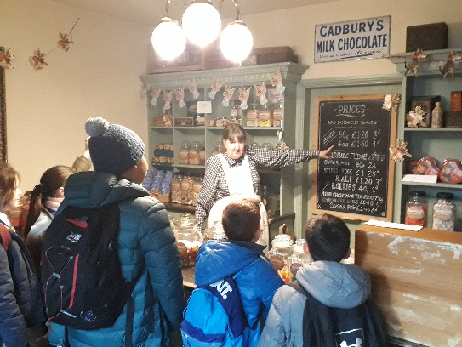

We enjoyed our school trip to Ironbridge. We learnt lots of different things about the Victorians. The experience was truly memorable and every moment was amazing! We went to a village with cosy little shops that sold various Victorian items. Also, there was a school room, the teacher was really strict, were we learnt very basic education. It was such a fun-filled day!
By Class 5/6B

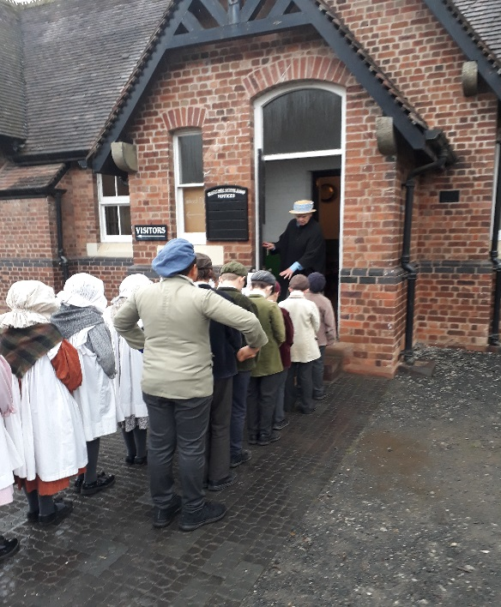

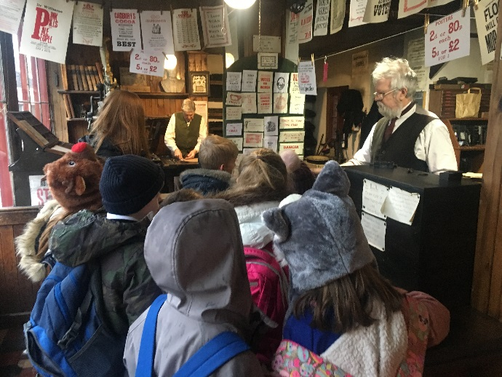

I have enjoyed the prefect jobs and the responsibility that comes with them. I am looking forward to continuing my role as lunch monitor and buddy throughout the year.
Lauren 5/6R

I have liked writing stories because it is really good fun.
Alexandra 3/4W
I really enjoyed caving in Colomendy because it was really interesting.
Oliver S 3/4W

I really liked watching Carrie’s War because she screamed when the house was on fire!
Mia 3/4W
I have enjoyed writing poems because they are fun and you can make them rhyme!
Olivia 3/4W

I like doing PE. I like throwing balls and catching them and running on the line.
Zach F2 BU

We have really enjoyed our Year 3/4 Christingle as we learnt all about different Christmas traditions from across the world. Also, we enjoyed our WW2 day because we got to dress up and sing songs.  Science has been another subject we have liked because we got to do lots of fun and exciting experiments.  Alexander & Autumn 3/4CW | I have liked making new friends and playing with them in the classroom and outside.  Georgia F2Bi  I have liked exploring new books in the book corner and playing funny games with my buddy.  Annabelle F2Bi | “We really enjoyed it when Chester Zoo came to visit us because we learnt lots of facts and we were able to hold insects.  It made me feel more confident doing Science and made us want to visit or work there when we are older.”  Adam & Skye 1/2B

Fit  Fun  Fest  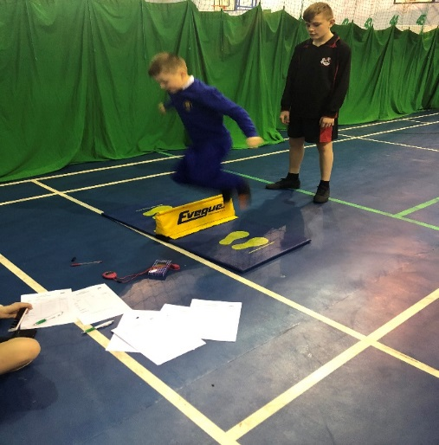  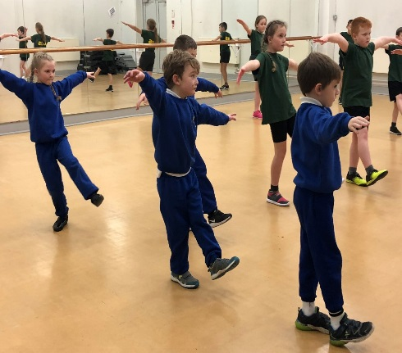 | Four children from 3/4 went to Birkenhead Park school to participate in Fun Fit Fest. The children took part in new age curling, trampolining and dance. The children had a great time learning new skills and improving their understanding of fitness.
I like the ‘Fortnite’ dances that we learnt because I play ‘Fortnite’ and I liked to shoe everyone the dances I knew.
Alex 3/4W

I like the trampoline because it was so bouncy and we had to try and stay in the middle of the cross and bounce 20 times! It was quite challenging!
Oliver 3/4W

I like going on the trampoline because it was fun and I like to bounce on my trampoline at home.
Daisy 3/4C

Year 5/6 Athletics

On Wednesday 7th November, a team of Year 5 and 6 girls and boys went to Bebington High Sports College to represent St. Peter’s in the Indoor Athletics Wirral Competition. We were competing in the third of four heats against three other schools. The children took part in both field events including: javelin, speed bounce, long jump and triple jump and relay running events. Throughout the afternoon, the children were tremendously supportive of one another and displayed fantastic skills and enthusiasm. St. Peter’s were announced in first place from heat 3 but we had to wait another day to find out the results after all schools had competed.
When the results came, we were delighted to find out that out of the 19 Wirral schools who had participated, St. Peter’s had finished 1st. As a result, St. Peter’s will now represent Wirral in the Merseyside finals in the Spring term.
Congratulations to all the athletes who took part.

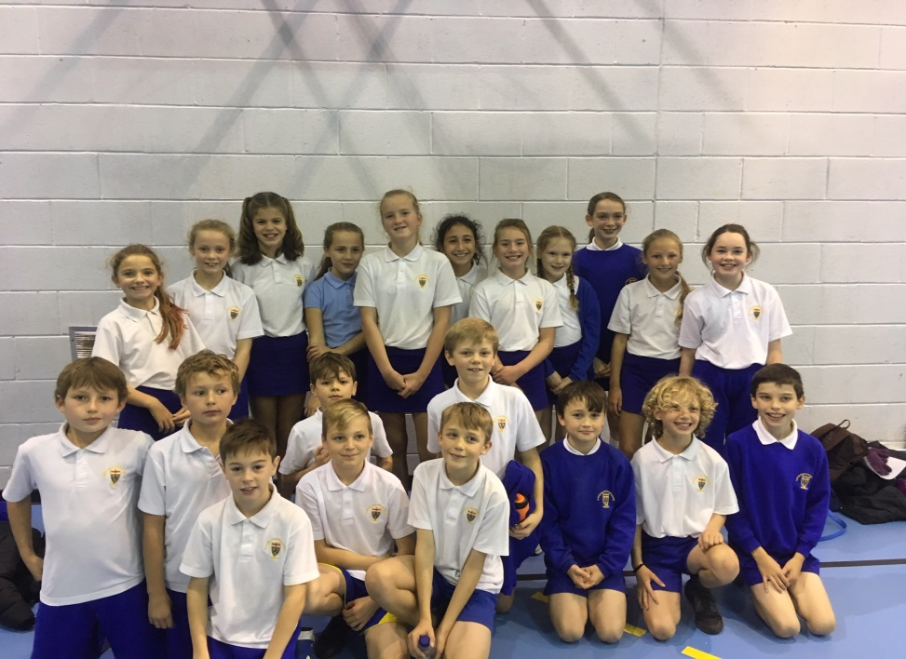

Our fantastic Year 5/6 Athletic Squad!

World War 2 Day  9th October 2018  Year 3/4 have loved learning about ‘World War 2’ this term.  A highlight was our ‘World War 2 Day’ where the children came to school dressed as evacuees and learnt exactly what it would have been like for a child growing up during this time.  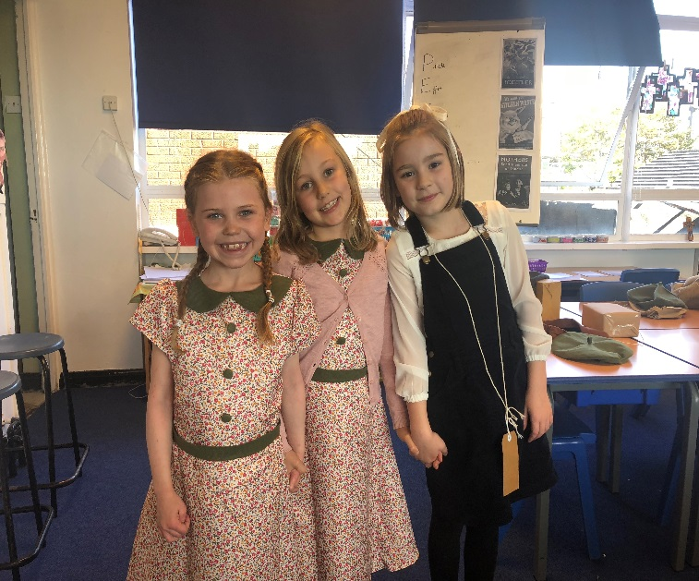  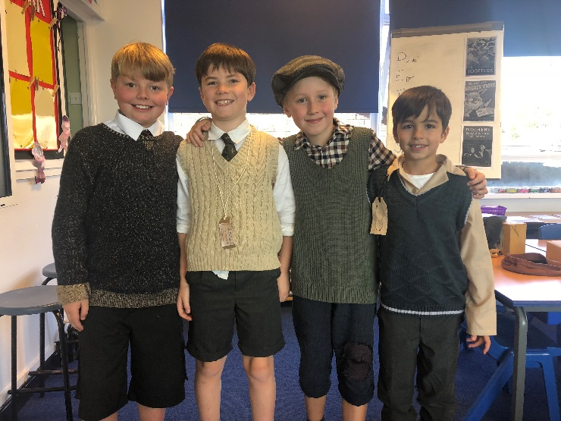  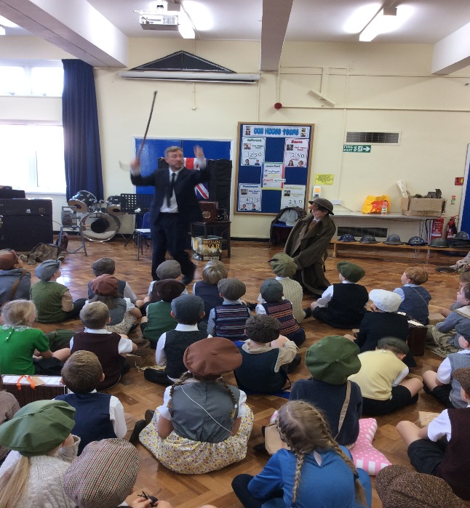 | Year 5 CPAS  Ventures  Residential  On Friday 12th October a group of twelve Year 5 pupils joined children from three other Church schools, for weekend residential at ‘Barnstondale’.  During the visit the children had the opportunity to be involved in a variety of activities which included climbing, archery, craft and songs around the campfire. The main focus for the weekend was ‘3,2,1… God, The World and Us’. Using texts from the Bible the children developed their knowledge of what Christians believe, further developed their understanding of the Christian faith and reflected on what Christians believe and how it relates to their understanding of the world and themselves. The weekend was a huge success and the children thoroughly enjoyed every aspect. Miss Partridge and I were very proud of all the children who attended from St. Peter’s, their contributions throughout the weekend were excellent.  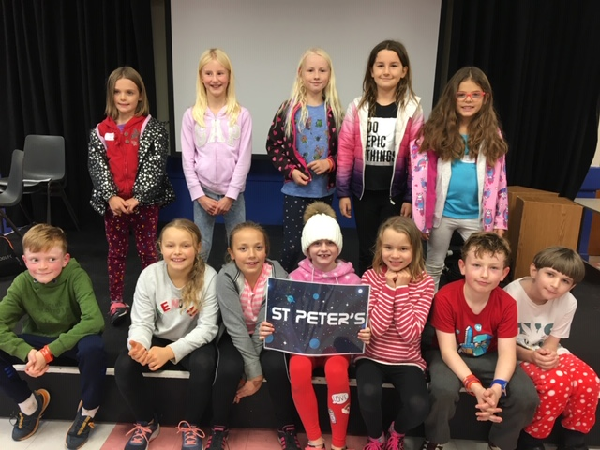
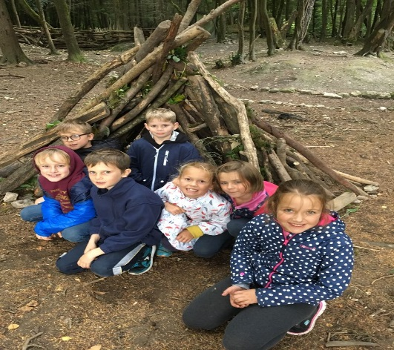
Year 4 Colomendy Residential

Kingswood Centre in Colomendy, North Wales was the destination of our Year 4 Residential in September. The children were still getting into the swing of being back in school as they headed off for a three-day fun filled residential. The activities proved to be challenging but everyone had lots of fun. Team work and collaborative skills were top of the list with the children continuing to build relationships as a class. It was a tiring but exciting few days which gave the children an excellent start to their school year.

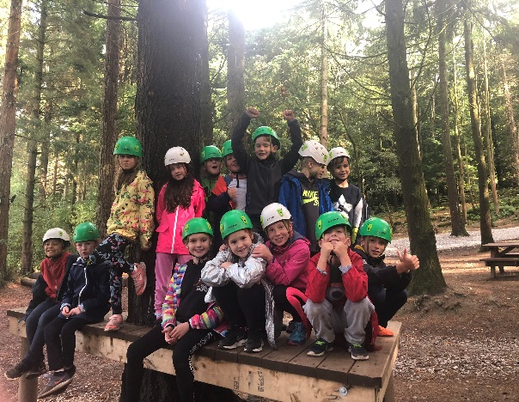

The Great Exhibition Year 5 & 6

The children in Year 5 & 6 have thoroughly enjoyed their topic on ‘Victorians’ this half term. Their work culminated in their very own ‘Great Exhibition’ held around school. The children had great fun with their homework task which was to create their own model of something that had been invented during the Victorian times. Once created the children had also been asked to research it. With much excitement and enthusiasm, the children invited their parents and grandparents to attend an exhibition, where all exhibits were displayed. During the exhibition, other events about Victorians were also going on. As always, the event was a huge success with numerous comments being made about the quality of the exhibits and the attention to detail that had been put in by the children.
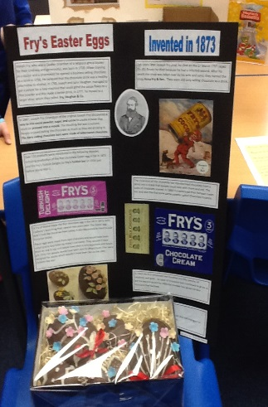
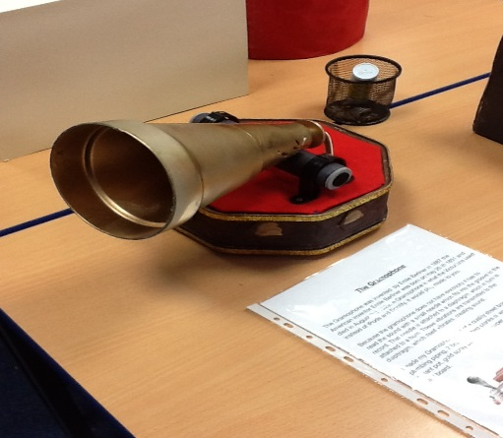
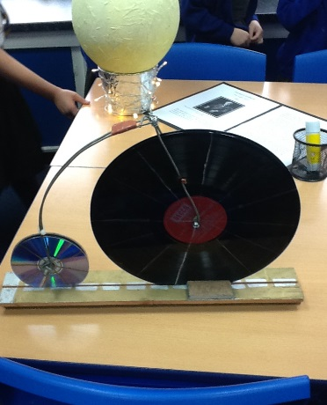
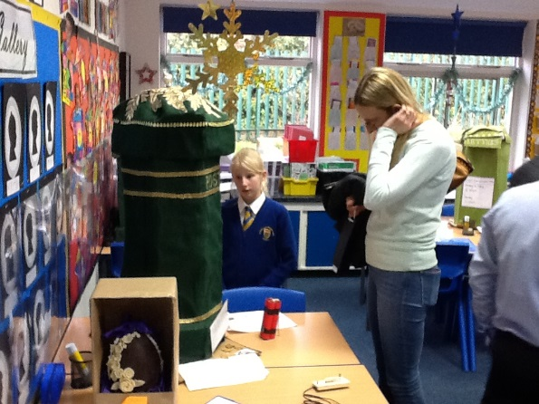

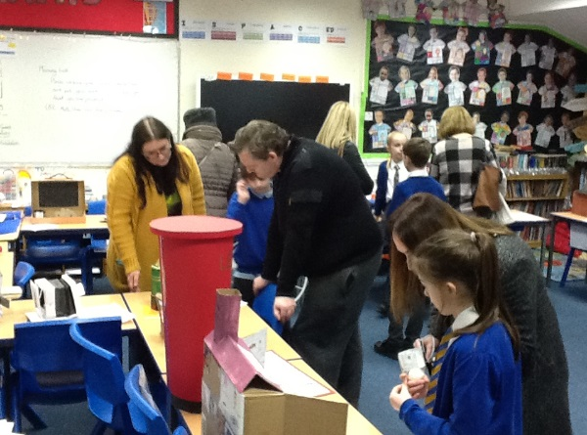

… and finally a Christmas Wish to you all

You are warmly invited to attend the Christmas Services at either of our two parish churches during the Christmas season. The two crib services on Christmas Eve are at – The Church of the Good Shepherd at 3pm or St. Peter’s Church at 4.30pm.

On behalf of myself, the staff and governors at St. Peter’s School, may I wish you a very Merry Christmas and a Happy and Healthy New Year for 2019.

Darren Jones
Headteacher

