Handwriting
This website shows how each letter should be formed.
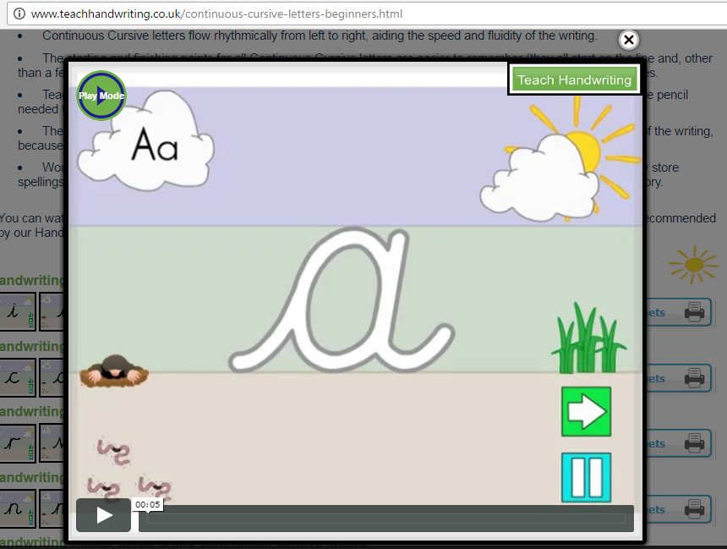
http://www.teachhandwriting.co.uk/continuous-cursive-letters-beginners.html

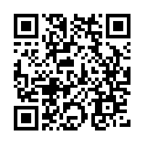

Handwriting Apps
There are many handwriting apps available (android and apple), however the one below is particularly good.
Cursive Writing Wizard (£2.99 but there is a free demo version, Cursive Writing Wizard Letters, if you want to try it out first).
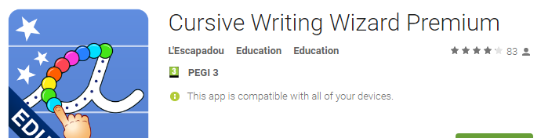

Maths Websites
- Family Maths Toolkit - Suggestions for activities/games that can be done at home to support maths: http://www.familymathstoolkit.org.uk/activities-for-children
- Busythings – ages 6-7 maths: https://www.busythings.co.uk/play/#
- BBC Bitesize games: http://www.bbc.co.uk/bitesize/ks1/maths/
- Topmarks – maths games (5-7 year olds): http://www.topmarks.co.uk/maths-games/5-7-years/addition-and-subtraction
- Maths zone: http://mathszone.co.uk/
- ICT Games: http://www.ictgames.com/resources.html

Apps:
There are lots of maths apps available for iPads and android devices, many of which are free. For example:
- Math Duel: 2 player math game (FREE)
- Math Bingo (free)
- Primary School Math age 7-8 UK (free)
- Squeebles times tables (£3.99)
- Motion math: hungry fish (£2.54)

