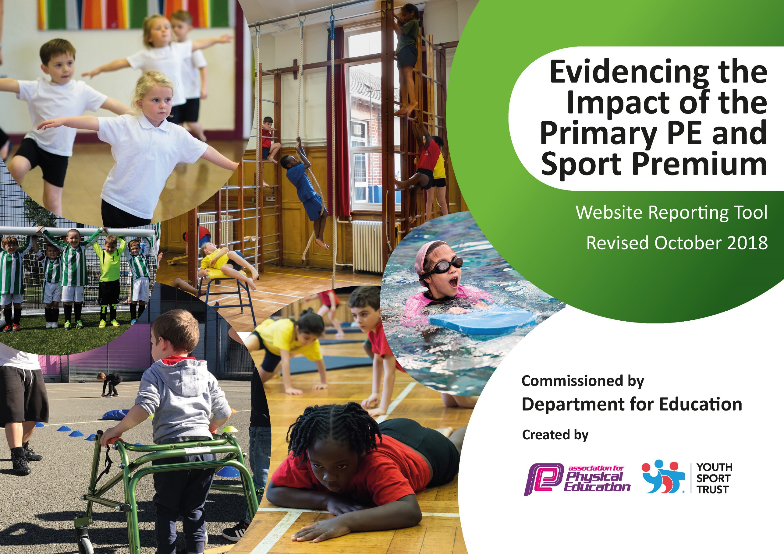
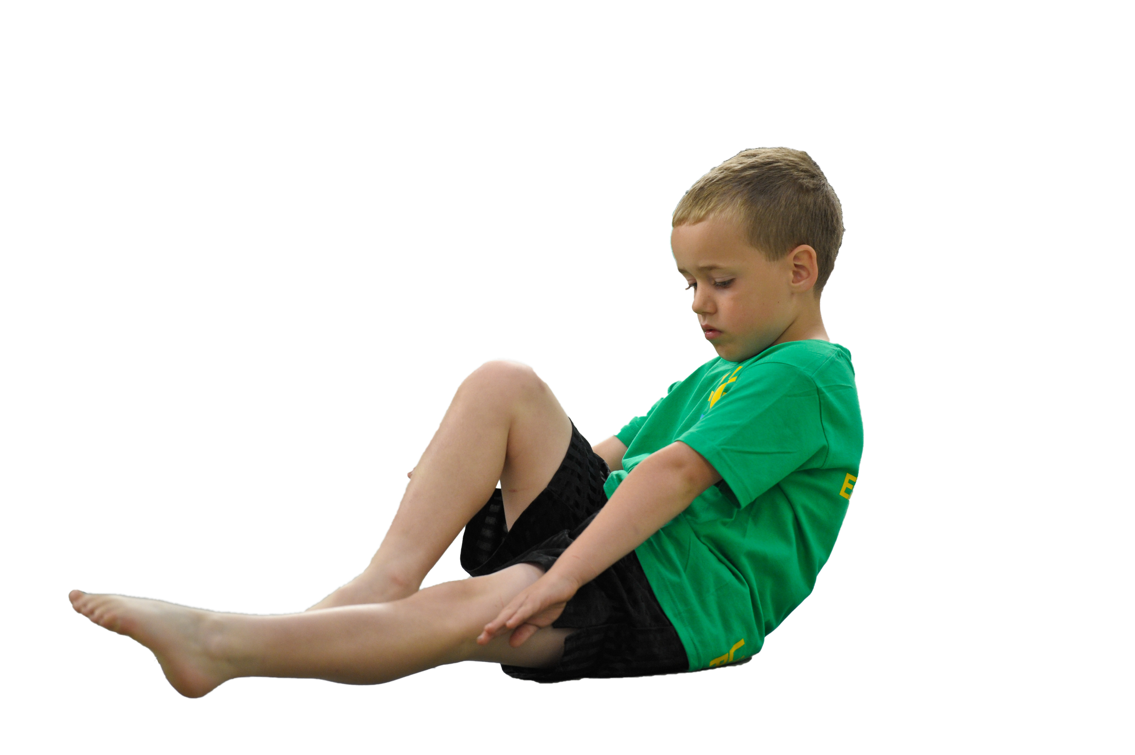
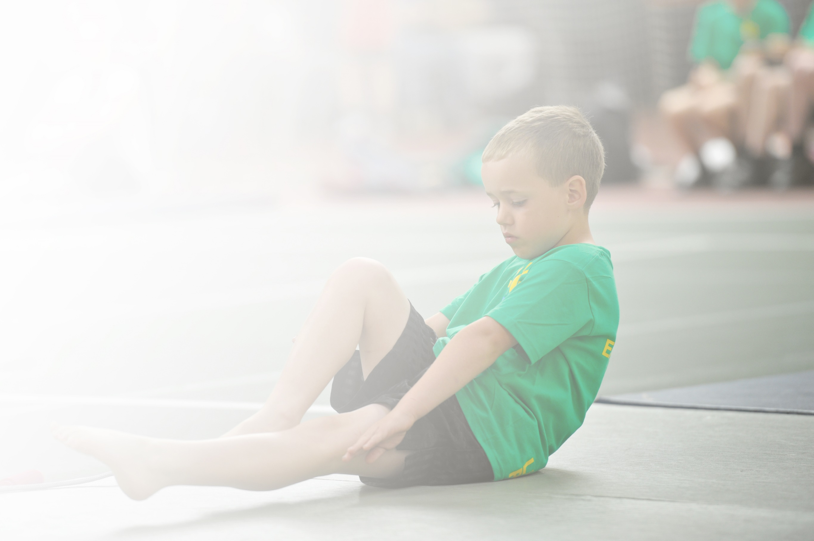
Schools must use the funding to make additional and sustainable improvements to the quality of Physical Education, Sport and Physical Activity (PESPA) they offer. This means that you should use the Primary PE and Sport Premium to:

- Develop or add to the PESPA activities that your school already offer
- Build capacity and capability within the school to ensure that improvements made now will benefit pupils joining the school in future years

Please visit gov.uk for the revised DfE guidance including the 5 key indicators across which schools should demonstrate an improvement. This document will help you to review your provision and to report
your spend. DfE encourages schools to use this template as an effective way of meeting the reporting requirements of the Primary PE and Sport Premium.

We recommend you start by reflecting on the impact of current provision and reviewing the previous
spend. Under the Ofsted Schools Inspection Framework, inspectors will assess how effectively leaders use the Primary PE and Sport Premium and measure its impact on outcomes for pupils, and how effectively governors hold them to account for this.

Schools are required to publish details of how they spend this funding as well as on the impact it has on pupils’ PE and sport participation and attainment by the end of the summer term or by 31 July 2019 at the
latest.
We recommend regularly updating the table and publishing it
on your website throughout the year, as evidence of your
ongoing review into how you are using the money to
secure maximum, sustainable impact. To see an
example of how to complete the table please
click HERE.

Support for review and reflection - considering the 5 key indicators from DfE, what development needs are a priority for your setting and your students now and why? Use the space below to reflect on previous spend, identify current need and priorities for the future.

Key achievements to date: | Areas for further improvement and baseline evidence of need:
School Gamesmark: Gold achieved for last 3 years  Active Playground relaunched with Playleader training and 47 plus children involved in leading activities  Daily ten activities started for KS2  Opportunities for competitive sport beyond level 1. (90% KS2 chn represented St. Peter’s 2018-19)  Teams qualified to represent Wirral at Cheshire/Liverpool City Region finals for Swimming, Sportshall Athletics, Quadkids, Quadkids Inclusive, Boccia & New Age Kurling.(2018-19) | Continue to target least active children to engage in physical activity both during the school day and after school. To enable all children to meet the Chief Medical Officer Guidelines of 30 minutes activity a day- some children find the team games too much and would prefer individual activities.  Staff training: to equip all staff with the skills needed to deliver PE as some are new since previous training.  Develop the mental wellbeing of children alongside the physical.  Greater range of extra-curricular activities for children (free) led by teachers/ TAs as there has been a drop in numbers of the paying clubs.  Extra swimming sessions to enable all Year 6 children to achieve the National Standard.  Sports Leaders trained and used in running competitions.

Meeting national curriculum requirements for swimming and water safety | Please complete all of the below:
What percentage of your current Year 6 cohort swim competently, confidently and proficiently over a distance of at least 25 metres?  N.B. Even though your children may swim in another year please report on their attainment on leaving  primary school. | 98%
What percentage of your current Year 6 cohort use a range of strokes effectively [for example, front crawl, backstroke and breaststroke]? | 98%
What percentage of your current Year 6 cohort perform safe self-rescue in different water-based situations? | 98%
Schools can choose to use the Primary PE and Sport Premium to provide additional provision for swimming but this must be for activity over and above the national curriculum requirements. Have you used it in this way? | Yes/No Yes extra sessions paid for 6 children to enable them to try achieve the standard.

Action Plan and Budget Tracking
Capture your intended annual spend against the 5 key indicators. Clarify the success criteria and evidence of impact that you intend to measure to evaluate for students today and for the future.

Academic Year: 2018/19 | Total fund allocated: £ | Date Updated:
Key indicator 1: The engagement of all pupils in regular physical activity – Chief Medical Officer guidelines recommend that primary school children undertake at least 30 minutes of physical activity a day in school |  |  |  | Percentage of total allocation:
 |  |  |  | 78%
School focus with clarity on intended impact on pupils: | Actions to achieve: | Funding allocated: | Evidence and impact: | Sustainability and suggested next steps:
Active Play activities to encourage a wider range of children, especially girls and ‘non-footballers’ to participate.  New resources in the playground to be used during break time/ lunch times and lessons to enable more children to become active.  Cardio and strengthening activities.  Use of physical activity in the classroom to make children more active in lessons to achieve 30 minutes of physical activity a day.  Daily ten activities for all children to improve fitness and to contribute to 30 minutes of activity every day.  Promote Get Set Tokyo and C4L programs. | Provide a range of equipment targeted at engaging different children.  Silent Disco to enable those children who enjoy dance to be able to be active during lunch time.  Play leader training to equip 50+ play leaders to have the confidence to lead and run activities during lunch time.  Buy outdoor gym equipment.  Use of Wake up and Shake up activities every morning.  Use of Supermovers to add activity to maths and English lessons.  Daily ten running track to be made on the field to enable the children to take part in daily ten in all weather conditions.  Resources given out (booklets)  Use of resources online.  Activities to promote activity at home. | £2000  £1300  £0  £10,000  (Either the gym equipment or the  running track will be ordered depending upon the overall costs)  £0  £ 10,000  (Either the gym equipment or the  running track will be ordered depending upon the overall costs)  £0 | Data collection on participation.  Play leader input.  Evidence from Sports Apprentice.  Midday Supervisor evidence.  Pupil voice.  Children more active data collected about participation.  Pupil voice.  Pupil voice.  Personal best of improvements to fitness levels.  Children have a greater understanding of how to be healthy through nutrition and fitness.  Family involvement. | Pupil voice through Sports Crew to feedback about equipment they would like to use.  Replacement of damaged equipment and buying of new resources.  Replacement headphones may need to be bought.  Teacher to be present during training to be able to deliver training next year.  Maintain and check equipment  New activities and initiatives introduced. PE coordinator to monitor what is being used.  Activities to keep evolving to maintain interest.  Link to Daily Mile.  Ongoing links with C4L and use of resources.
Key indicator 2: The profile of PESSPA being raised across the school as a tool for whole school improvement |  |  |  | Percentage of total allocation:
 |  |  |  | 7%
School focus with clarity on intended impact on pupils: | Actions to achieve: | Funding allocated: | Evidence and impact: | Sustainability and suggested next steps:
To offer wide range of sporting opportunities to children for both physical and mental health benefits as well as personal development.  School Games Mark. Gold mark to be achieved and then Platinum level.  Pupils engaged in planning of PE and school sport.  Children in Year 6 able to meet National Standards for Swimming. | Administration to organize club timetables for year, play leader rotas and activities etc. Preparation of club/course/competition letters, registers each half term etc.  Use of Iceberg programme to empower children to increase their confidence  and self-worth for optimum mental and physical wellbeing. To develop the links between physical activity and mental health.  Wellbeing days for all children – range of activities planned.  Case study will need to be done.  Sports Leaders to be trained  Records kept and evidence gathered.  Sports Crew meetings and pupil voice.  Assessment of children in Year 6 and extra sessions put on for those not at required standard above normal swimming lessons. | £0  £750  £180 (PE tablet)  £0  £300 | Range of opportunities provided Pupil participation data  Pupil Voice  Parental feedback  School Games Mark level achieved  High % of Year 6 children achieving National Standard of swimming. | Children physical and mentally healthy and resilient and engaged with learning. Children adopt lifelong healthy lifestyles.

Key indicator 3: Increased confidence, knowledge and skills of all staff in teaching PE and sport |  |  |  | Percentage of total allocation:
 |  |  |  | 4%
School focus with clarity on intended  impact on pupils: | Actions to achieve: | Funding  allocated: | Evidence and impact: | Sustainability and suggested  next steps:
Whole school staff CPD Improved quality of children's physical education in Key Stage 1/2 to ensure staff are competent and confident.  Subject leader update/networking Professional development in subject leadership for PE subject leader | Discussions with staff regarding CPD needs.  Staff meetings arranged to meet this need or individual support.  Access Subject leader training/conferences & updates as available during the year | £500  £200 | Improve quality of teaching and staff confidence. Lesson observations.  Subject Leader up-to-date with information needed for curriculum improvement/development and sporting opportunities available. | PE Subject Leader monitor and provide support as appropriate in order to ensure progress and achievement are maintained by all pupils.
Key indicator 4: Broader experience of a range of sports and activities offered to all pupils |  |  |  | Percentage of total allocation:
 |  |  |  | 4%
School focus with clarity on intended  impact on pupils: | Actions to achieve: | Funding  allocated: | Evidence and impact: | Sustainability and suggested  next steps:
Continue to develop the range of extra-curricular activities on offer to the children. | Free clubs run by staff to target children who do not already take part in activities.  Financial support for some activities.  Additional clubs run by teacher. Use sports leaders to help run clubs.  Pupil voice about activities wanted. | £700  £0 | % evidence data  Club links – children move on to train with local clubs organizations | By providing a range of varied opportunities and inspiring our children to get involved in regular physical activity we aim to lay the foundations to a healthy, active lifelong lifestyle.
Key indicator 5: Increased participation in competitive sport |  |  |  | Percentage of total allocation:
 |  |  |  | 7%
School focus with clarity on intended  impact on pupils: | Actions to achieve: | Funding  allocated: | Evidence and impact: | Sustainability and suggested  next steps:
Wirral School Games Events (opportunities for more able children/SEN)  Competitions with local schools.  Regular intra competitions held in a range of sports as part of lessons/Sports Days. | Funding for staff supply  Sports Leaders to help referee and organize competitions. | £1000  £200 for t-shirts  £0 | Higher % of children representing the school in Level 2 and County level events (level 3).  SEN children and less engaged children targeted to make sure all children in Year 6 have an opportunity to represent the school. | Parental help with transport to prevent money needing to be spent on transport costs.  Events held after school when possible to avoid supply being needed.

