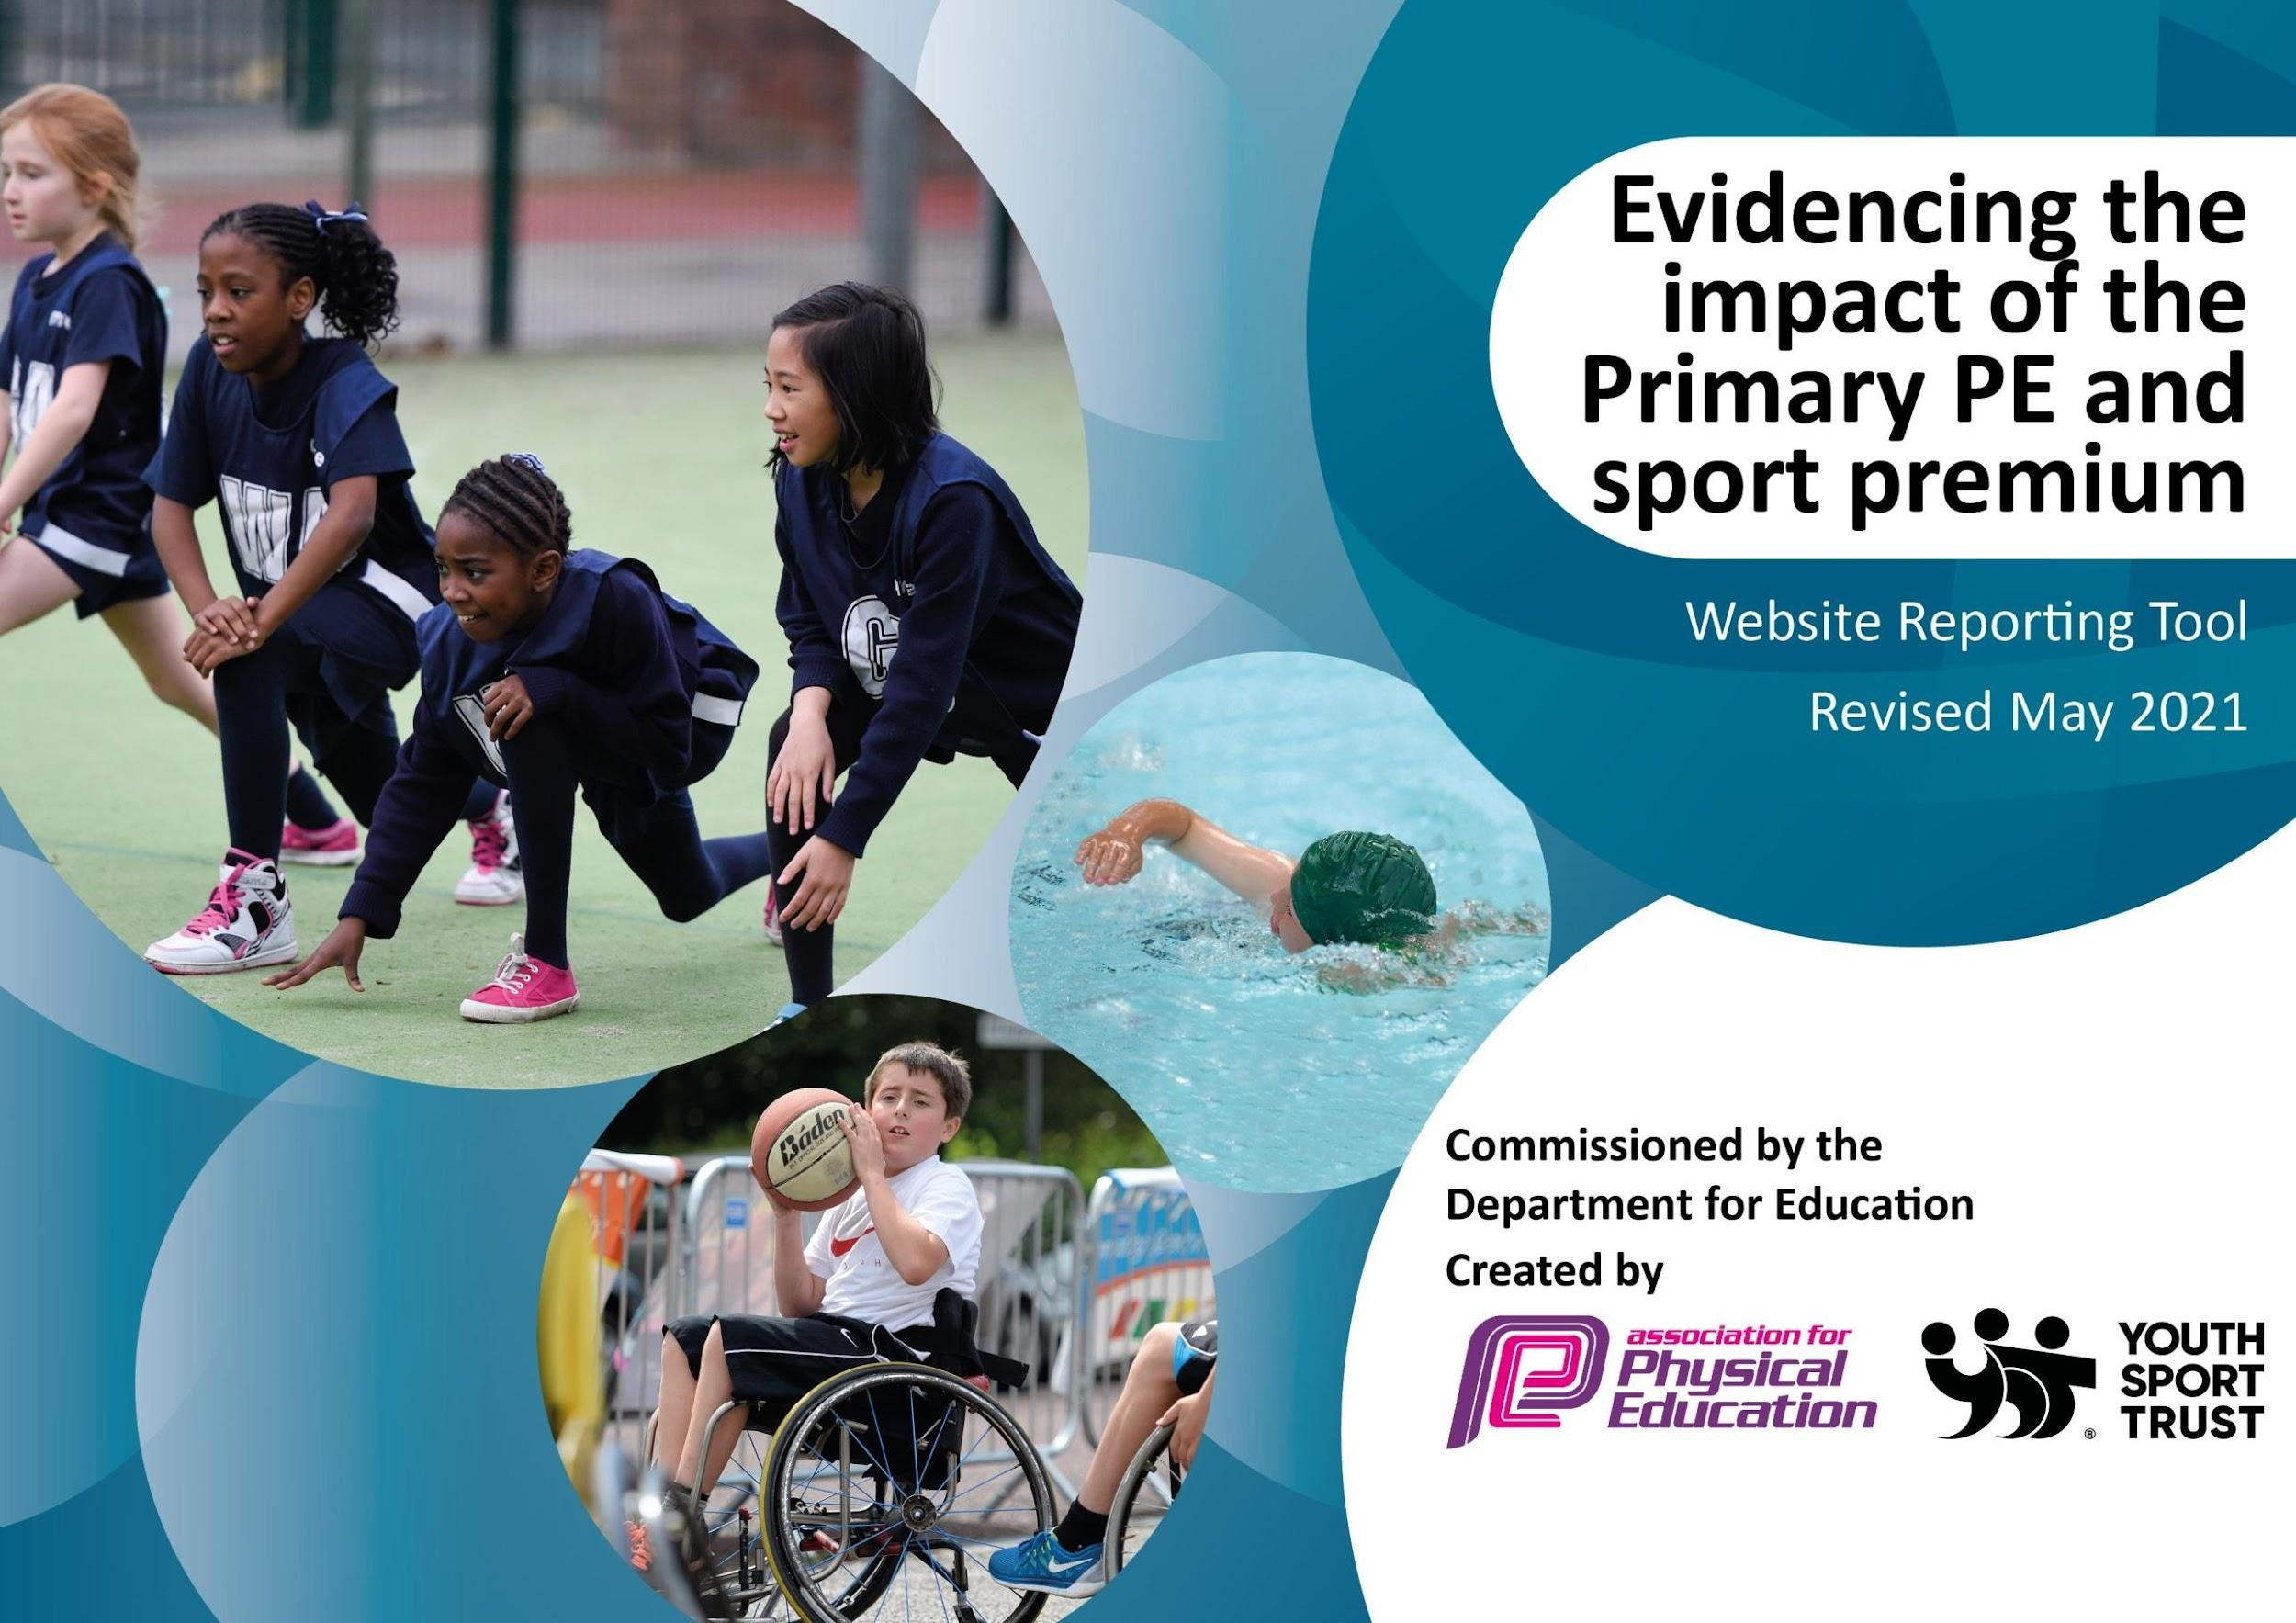

It is important that your grant is used effectively and based on school need. The Education Inspection Framework (Ofsted 2019 p64) makes clear there will be a focus on **‘whether leaders and those responsible for governors all understand their respective roles and perform these in a way that enhances the effectiveness of the school’**.

Under the Quality of Education criteria (p41) inspectors consider the extent to which schools can articulate their curriculum (INTENT), construct their curriculum (IMPLEMENTATION) and demonstrate the outcomes which result (IMPACT).

To assist schools with common transferable language this template has been developed to utilise the same three headings which should make your plans easily transferable between working documents.

Schools must use the funding to make **additional and sustainable** improvements to the quality of Physical Education, School Sport and Physical Activity (PESSPA) they offer. This means that you should use the Primary PE and sport premium to:

* Develop or add to the PESSPA activities that your school already offer
* Build capacity and capability within the school to ensure that improvements made now will benefit pupils joining the school in future years
* The Primary PE and sport premium should not be used to fund capital spend projects; the school’s budget should fund these.

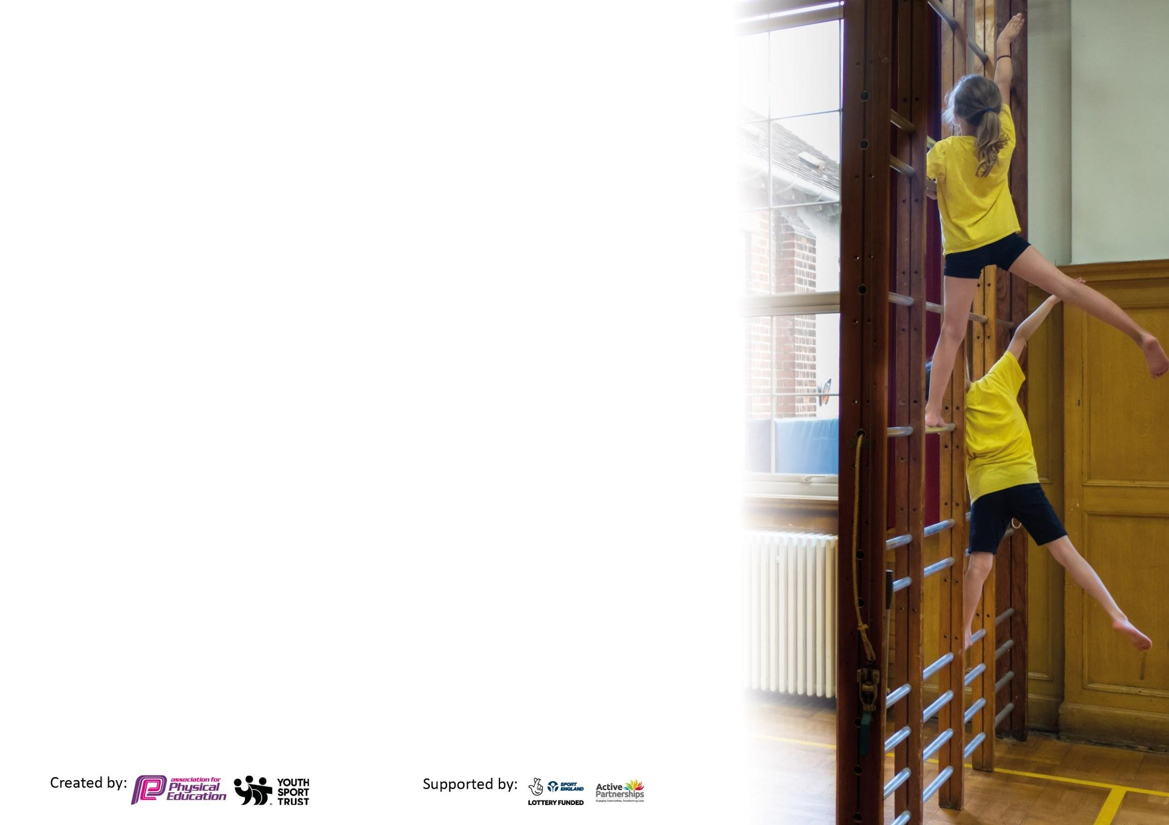

Please visit gov.uk for the revised DfE guidance including the 5 key indicators across which schools should demonstrate an improvement. This document will help you to review your provision and to report your spend. DfE encourages schools to use this template as an effective way of meeting the reporting requirements of the Primary PE and sport premium.

We recommend you start by reflecting on the impact of current provision and reviewing the previous spend.

Schools are required to publish details of how they spend this funding, including any under-spend from 2019/2020, as well as on the impact it has on pupils’ PE and sport participation and attainment by the end of the summer term.

We recommend regularly updating the table and publishing it on your website throughout the year. This evidences your ongoing self-evaluation of how you are using the funding to secure maximum, sustainable impact. Final copy must be posted on your website by the end of the academic year. To see an example of how to complete the table please click HERE.



|  |  |
| --- | --- |
| Meeting national curriculum requirements for swimming and water safety.  N.B Complete this section to your best ability. For example you might have practised safe self-rescue techniques on dry land which you can transfer to the pool when school swimming restarts.  **Due to exceptional circumstances priority should be given to ensuring that pupils can perform safe self rescue even**  **if they do not fully meet the first two requirements of the NC programme of study.** | 100% (2024 outcomes) |
| What percentage of your current Year 6 cohort swim competently, confidently and proficiently over a distance of at least 25 metres?  **N.B.** Even though your pupils may swim in another year please report on their attainment on leaving primary school at the end of the summer term 2023.  Please see note above. | 100% |
| What percentage of your current Year 6 cohort use a range of strokes effectively [for example, front crawl, backstroke and breaststroke]?  Please see note above. | 100% |
| **What percentage of your current Year 6 cohort perform safe self-rescue in different water-based situations?** | 100% |
| Schools can choose to use the Primary PE and sport premium to provide additional provision for swimming but this must be for activity **over and above** the national curriculum requirements. Have you used it in this way? | No |

**Action Plan and Budget Tracking**

Capture your intended annual spend against the 5 key indicators. Clarify the success criteria and evidence of impact that you intend to measure to evaluate for pupils today and for the future.

|  |  |  |  |  |
| --- | --- | --- | --- | --- |
| **Academic Year:** 2024/25 | **Total fund allocated:** £18,390 | **Date Updated: TBC** | |  |
| **Key indicator 1:** The engagement of all pupils in regular physical activity – Chief Medical Officers guidelines recommend that primary school pupils undertake at least 30 minutes of physical activity a day in school | | | | Percentage of total allocation: |
| % |
| **Intent** | **Implementation** | | **Impact** |  |
| Your school focus should be clear what you want the pupils to know and be able to do and about what they need to learn and to consolidate through practice: | Make sure your actions to achieve are linked to your intentions: | Funding allocated: | Evidence of impact: what do pupils now know and what can they now do? What has changed?: | Sustainability and suggested next steps: |
| Increase activity levels of all pupils  during the school day | Appointment of Sports Co-Ordinator (CH), creation of non-contact time weekly to organise sports tournaments plus additional staffing costs for staff attendance at tournaments. | Included in CH costs (£6000) | **Impact:**  **Evidence:** |  |
| Playleaders achieving and delivering the playmaker programme via Edsential | £850 | **Impact:**  **Evidence:** |  |

|  |  |  |  |  |
| --- | --- | --- | --- | --- |
| **Key indicator 2:** The profile of PE being raised across the school as a tool for whole school improvement | | | | Percentage of total allocation: |
| % |
| **Intent** | **Implementation** | | **Impact** |  |
| The Flourish (formerly Thumbs Up) Education Programme is presented in schools to enable primary school children to develop a healthy mental and emotional wellbeing by using CBT techniques and confidence building | Used as an intervention for targeted pupils to develop their resilience | £1050 | **Impact:**  **Evidence:** |  |
| To offer wide range of sporting opportunities to children for both physical and mental health benefits as well as personal development. | Administration to organize club timetables for year, play leader rotas and activities etc. Preparation of club/course/competition letters, registers each half term etc. | Included in CH costs (£6000) | **Impact**:  **Evidence:** |  |
| School Games Mark. Gold mark to be achieved, then Platinum level | CH to work toward maintaining this. | Included in CH costs (£6000) | **Impact:**  **Evidence:** |  |
| Children in Year 6 able to meet National Standards for Swimming. (catch-up sessions) | SJP through her sport coach role | £1315 catchup swimming cost | **Impact:**  **Evidence:** |  |
| Y6 pupils participate in Rainbow transition programme to support secondary transition using clips, mindfulness, yoga, and fun challenges. Children learn about brain health, resilience, coping with difficult emotions, trust, support and being a leader of themselves. | Edsential Programme | £920 | **Impact:**  **Evidence:** |  |

|  |  |  |  |  |
| --- | --- | --- | --- | --- |
| **Key indicator 3:** Increased confidence, knowledge and skills of all staff in teaching PE and sport | | | | Percentage of total allocation: |
| % |
| **Intent** | **Implementation** | | **Impact** |  |
| Your school focus should be clear | Make sure your actions to | Funding | Evidence of impact: what do | Sustainability and suggested |
| what you want the pupils to know | achieve are linked to your | allocated: | pupils now know and what | next steps: |
| and be able to do and about | intentions: |  | can they now do? What has |  |
| what they need to learn and to |  |  | changed?: |  |
| consolidate through practice: |  |  |  |  |
| Improve staff knowledge and confidence when teaching curriculum PE | Edsential Scheme of work to support teaching of lessons, include knowledge organisers, progression documents and assessment tool. | £350 | **Impact:**  **Evidence:** |  |
| Ongoing CPD from SJP in delivering PE curriculum | Included in CH costs (£6000) | **Impact:**  **Evidence:** |  |
| Subject Leader to stay up to date with local and national developments within area.  Children will become more active by attending clubs.  Impact on all other areas including increased participation, improved teaching and learning and effective use of PE funding. | Edsential Subject Leader Support Programme:  Termly meeting to support PE Subject Leader  Ongoing advice and guidance  Analysis of participation  Learning Walks and Observations | £800  £1500 release time for Subject Leader | **Impact:**  **Evidence:** | . |

|  |  |  |  |  |
| --- | --- | --- | --- | --- |
| **Key indicator 4:** Broader experience of a range of sports and activities offered to all pupils | | | | Percentage of total allocation: |
| % |
| **Intent** | **Implementation** | | **Impact** |  |
| Your school focus should be clear | Make sure your actions to | Funding | Evidence of impact: what do | Sustainability and suggested |
| what you want the pupils to know | achieve are linked to your | allocated: | pupils now know and what | next steps: |
| and be able to do and about | intentions: |  | can they now do? What has |  |
| what they need to learn and to |  |  | changed? |  |
| Consolidate through practice: |  |  |  |  |
| Increase the number of children accessing extra curricular activity clubs | Full of Beans deliver after-school clubs for KS1 and KS2 provide new opportunities to support physical development and increase the range of sporting activities on offer | £4204 | **Impact:**  **Evidence:** |  |
| Equipment purchased:  Increase the amount of ‘basic’ PE equipment. | £1000 | **Impact:**  **Evidence:** |  |
| Ensure children can represent the school with pride. | Purchase of new sports kits for children when representing the school in sport e.g. football kits, cross country vests, netball tops etc. | £1000 | **Impact:**  **Evidence:** |  |

|  |  |  |  |  |
| --- | --- | --- | --- | --- |
| **Key indicator 5:** Increased participation in competitive sport | | | | Percentage of total allocation: |
| % |
| **Intent** | **Implementation** | | **Impact** |  |
| Your school focus should be clear | Make sure your actions to | Funding | Evidence of impact: what do | Sustainability and suggested |
| what you want the pupils to know | achieve are linked to your | allocated: | pupils now know and what | next steps: |
| and be able to do and about | intentions: |  | can they now do? What has |  |
| what they need to learn and to |  |  | changed?: |  |
| consolidate through practice: |  |  |  |  |
| Increase the number of pupils accessing competitions | SJP organisation and attendance at:  Edsential ‘Competitions for All’ Programme  Wirral School Games  Other local competitions | Included in CH costs (£6000)  +£350 PE subs for competition participation | **Impact:**  **Evidence**: |  |
| Increase the number of pupils achieving National Curriculum standards in School Swimming | Top Up sessions in Year 6 for pupils who haven’t yet achieved. | £1315 catchup swimming cost | **Impact:**  **Evidence**: |  |

**Total: £18,390**

**Planned Spend: £19,289**

**Difference: -£899**

|  |  |
| --- | --- |
| **Signed off by** | |
| **Head Teacher:** | D Wallace |
| **Date:** |  |
| **Subject Leader:** | C Hesketh |
| **Date:** |  |
| **Governor:** | S Nelson |
| **Date:** |  |