**ST. PETER’S CE PRIMARY SCHOOL, HESWALL**

**Charging Policy**

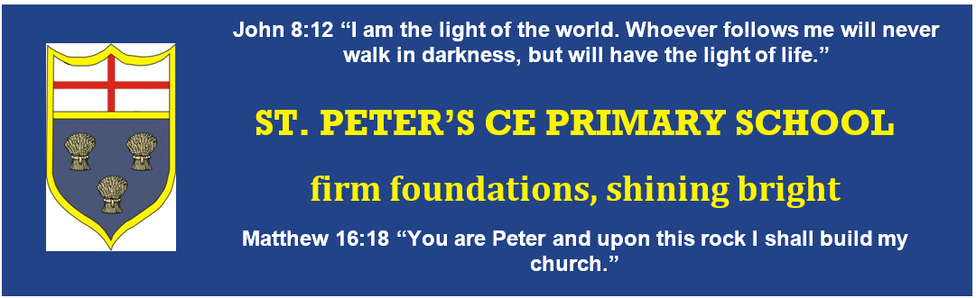





**2024 – 2024**

**Date Adopted: 21.11.23**

**Date of Review: November 2025**

**Committee: Assets**

**Introduction**

This charging policy has been compiled in line with DFE requirements and in accordance with s457 of the Education Act, 1996.

## Basic Principles

No charge can be made for education during school hours. The definition of ‘education’ includes materials, equipment and transport provided in school hours by the Local Education Authority or the school to carry pupils between the school and the activity. ‘School hours’ are those when the school is actually in session, and do not include the break in the middle of the day.

School trips, visits and practical activities enhance the pupils’ learning and broaden their knowledge and experience. These are undertaken with the voluntary contributions of parents. No pupil will be excluded from an activity because his or her parents cannot or will not make a voluntary contribution. The opportunity to pay in instalments will be offered to parents who wish to pay in this way.

**Voluntary Contributions**

There is an exception to the rule about not charging for activities in school hours. Parents may be invited to make voluntary contributions to extend the value of school funds. An annual voluntary contribution is invited per child to cover the cost of smaller consumable items that the pupil will bring home and /or to subsidise or cover the cost of educational visits. The annual amount is determined by the Governing Body.

If a particular activity cannot take place without some help from parents, this will be explained at the planning stage. If a planned activity has to be cancelled any monies received will be returned. Contributions will not exceed the actual cost.

Examples where parents may be asked for a voluntary contribution include:

* School Trips
* Enrichment activities e.g. external drama group
* Art projects

**Swimming**

The school organises swimming lessons for children in Years 3 and 4. These take place in school time and are part of the National Curriculum. No charge is made for this activity including the cost of transport to the pool. Parents are informed when these lessons are to take place.

**School Meals**

Our school operates an in-house catering facility which is provided by Edsential. Children in Foundation 2, Year 1 and Year 2 are entitled to a free school meal via the Universal Free School Meals Scheme which is funded by the Government.

Our Foundation 1 children and our junior children in Years 3, 4, 5 and 6 are charged £2.80 per meal. These costs are paid via our online payment system, Parentpay.

If a child’s parent(s) is in receipt of certain benefits, they may be entitled to a free school meal. If this in the case then this information is fed into our online payment system and the child will receive a meal free of charge.

Staff and Visitors can have a school meal. These are charged at £2.80 per day.

**Foundation 1**

St. Peter’s has a Foundation 1 setting. At St Peter’s Early Years, we are able to offer all 3 and 4-year-old children their entitled Universal 15 hours per week free childcare (38 weeks per year). This takes effect the term after their 3rd birthday. We can provide all prospective parents with the relevant paperwork to apply for this. In addition, we offer the extended 15 hours per week free childcare, subject to eligibility.

**Tax-free childcare**

We are registered to accept payments for fees via the Tax-free Childcare Service. For every £8 you pay, the Government will pay £2.

**Fees**

Any sessions not covered by the Early Years funding will be charged at:

**Session - £19.50 Lunch time - £5.50 All day - £44.50**

Some working families may be entitled to a funded full-time place (30 hours). We also accept payments via Childcare Vouchers from a number of different providers. Please ask at the school office for further details on the providers currently used by the school.

**Ancillary Services**

The School may offer additional non-educational services and the scale of charges will be approved by the Governing Body on an annual basis. If the service is a one-off, the Head Teacher or Assets Committee may approve the charge.

**Remissions Policy**

* If the parent /carer of a pupil is in receipt of Free School Meals/Pupil Premium the Head Teacher or Governing Body may choose to remit charges in respect of a particular activity, if it feels it is reasonable in the circumstances i.e. included in one of the above categories. This does not apply in the case of pupils in receipt of the Government’s Universal Free School Meals not in receipt of Pupil Premium;
* If the pupil’s parent is in receipt of income support the charges in respect of board and lodging of a residential trip shall be remitted

**Extra-Curricular Activities run by External Providers**

External providers will set and collect their own charges.

**Other charges**

The Head Teacher, Assets Committee or Governing Body may levy charges for miscellaneous services up to the cost of providing such services e.g. photocopying.

**Breakages**

In cases of wilful or malicious damage to equipment or breakages, or loss of school books on loan to children, the Head Teacher in consultation with the Chair of the Governing Body may decide it right to make a charge. Each incident will be dealt with on its own merit and at their discretion.

The Head Teacher, Assets Committee or Governing Body may remit in full or part charges in respect of a pupil, if it feels it is reasonable in the circumstances.

**Exceptions**

The Head Teacher, Assets Committee or Governing Body may decide not to levy charges in respect of a particular activity, if it feels it is reasonable in the circumstances.

The Governors have made the decision not to charge ‘Friends of St. Peter’s’ for the use of school premises as any fundraising will benefit the school directly.

It is the responsibility of ‘Friends of St. Peter’s’ to obtain any appropriate licences (e.g. sale of alcohol etc).

**Lettings**

The school will make its facilities available to outside users at a charge of at least the cost of providing the facilities. The scale of charges will be approved annually by the Assets Committee.

**Scale of Charges**

These will be reviewed and approved by the Governing Body on an annual basis.

**Review**

This Policy will be reviewed annually as part of the review of the Financial Policies and Procedures.