
Digital Culture Survey Responses

There were 45 responses to the survey.
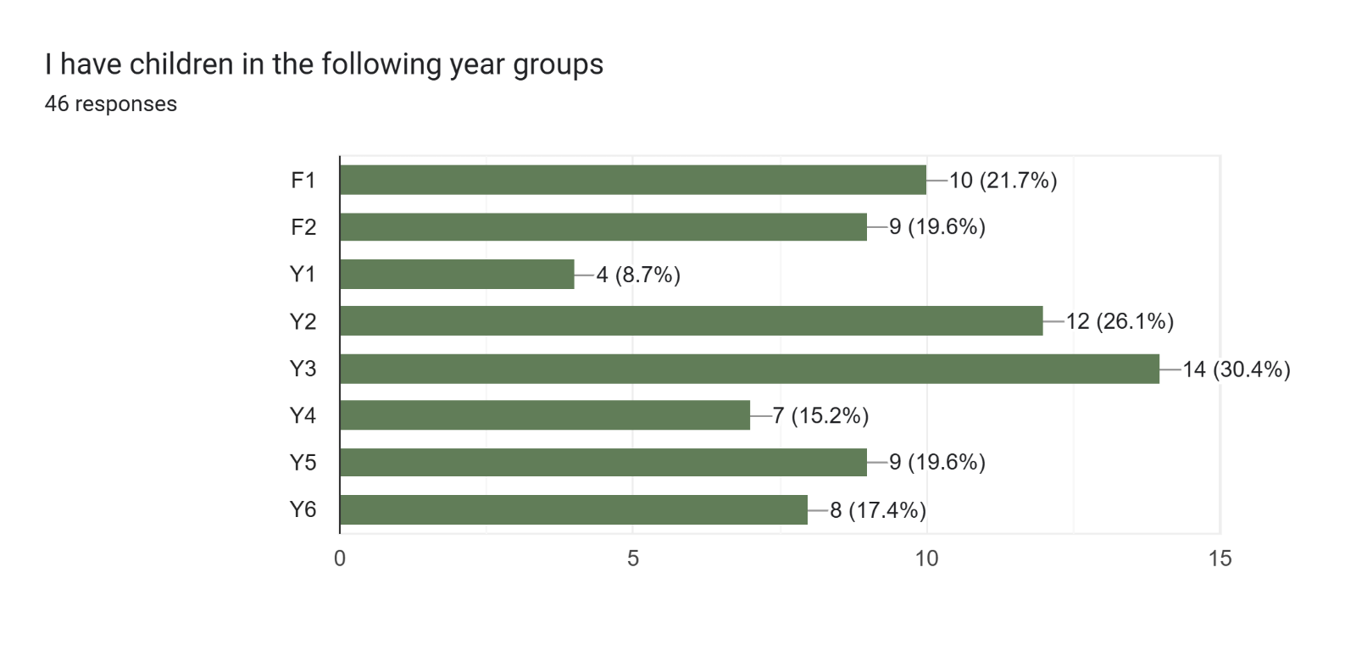
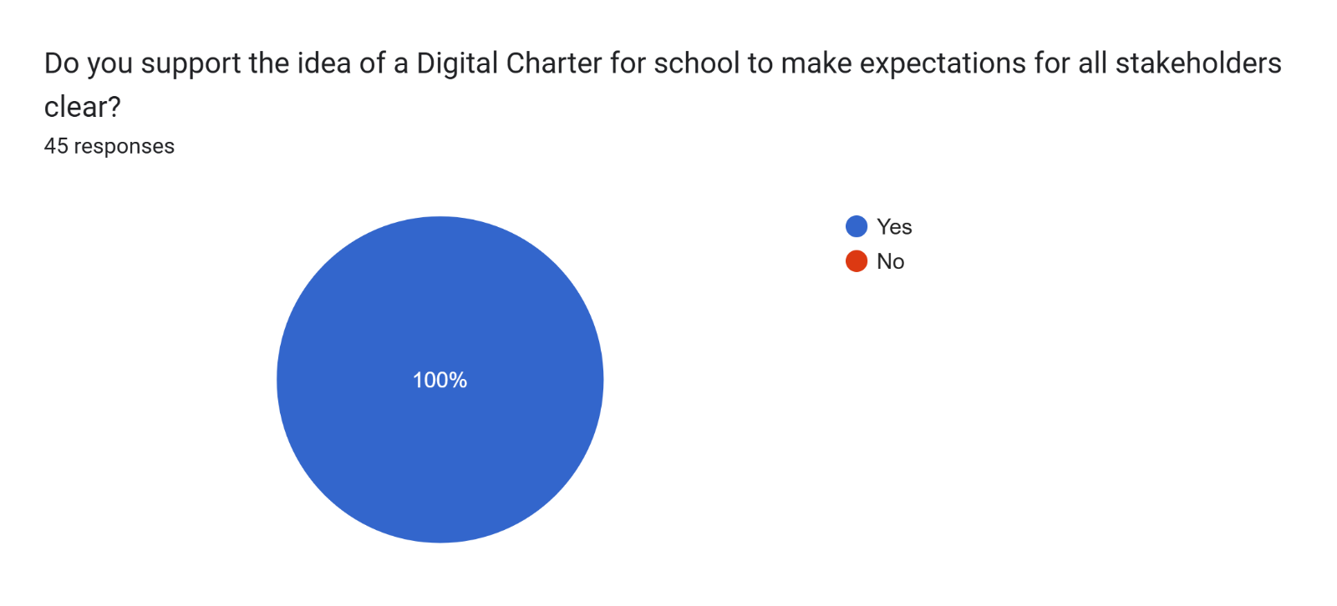
Key Themes in Stakeholder Feedback
- Stringent Phone Policies: There is a strong call for a total ban on smartphones on school premises, rather than just "encouragement." Parents suggest that if Year 6 pupils require phones for safety while walking home, these should be non-smart models. Furthermore, many requested that phones remain out of sight during pick-up/drop-off—both for pupils and parents—to avoid "performative" behavior and mixed messaging.
- Digital Privacy & Social Media: Concerns were raised about the school’s use of social media. Stakeholders questioned the necessity of posting children's faces for "publicity" and suggested making school groups private. There is a desire for the school to move away from an "opt-out" system toward a more robust defense of why children’s images are being shared at all.
- Classroom & Homework Limits: Respondents are keen to reduce overall screen time, specifically mentioning concerns about online testing, TV use in class, and the use of tablets for homework or lessons.
- External Platforms: There is a request to discourage large peer-to-year WhatsApp groups (due to the 13+ age rating) and to ensure that third-party after-school providers align with the school’s "phone-free" ethos.
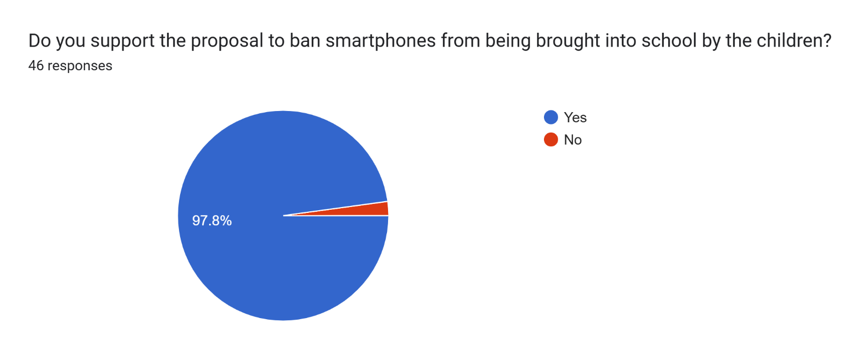
Key Themes in Stakeholder Feedback
- Safeguarding and Content: Parents are deeply concerned about children being exposed to inappropriate or harmful content via their own or a peer's device. A ban is seen as a necessary measure to ensure the school remains a "safe space."
- Social Development: There is a desire to "let children be children." Parents believe removing phones encourages face-to-face socialization, active play, and community interaction while reducing cyberbullying and social anxiety.
- Eliminating Peer Pressure: A universal ban levels the playing field, removing the socioeconomic and social pressure on parents to provide devices simply because "everyone else has one."
- Academic Focus: Smartphones are viewed as a "functional distraction" with no place in a learning environment.
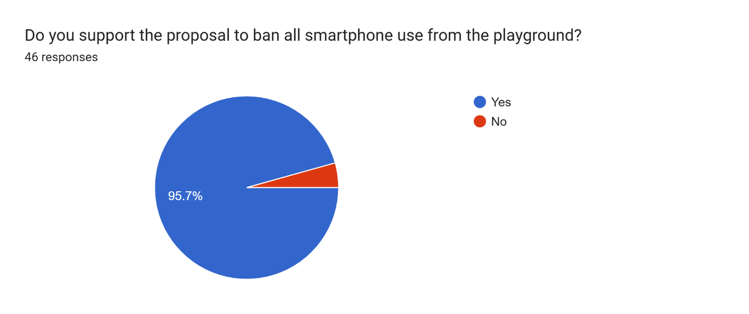
Key Themes in Stakeholder Feedback
- Leading by Example: The most frequent argument is that parents must "model" healthy behaviour. Contributors noted that "monkey see, monkey do" and that children cannot be expected to limit screen time if adults are constantly distracted.
- Social Connection & Reconnection: Many feel the ban would foster better interactions between parents and create a "culture of reconnection" when children finish their school day.
- Safety and Safeguarding: Concerns were raised about children being exposed to inappropriate content on screens or the potential for unsupervised digital interactions in a communal space.
- Practical Nuance: While mostly in favour, some parents raised valid logistical concerns:
  - Work/Life Balance: Several parents use the waiting time to finish work emails or need to remain reachable for emergencies.
  - School Events: Use of phones for digital payments (e.g., PTA events) would require specific exemptions.
  - Compromise: A suggestion was made to allow phone use while waiting, provided they are put away the moment children appear.
Key Themes in additional comments

Collective Accountability
Parents argue that for the culture to shift, adults must model the behaviour. This includes discouraging parent phone use on school grounds and ensuring the school’s own digital footprint (e.g., posting student photos) aligns with the low-tech message.

Education & Engagement
There is a concern that the school is "preaching to the converted." To reach parents who may be in denial, respondents suggest sharing regular, small "sound bites" of information that focus on what children miss out on—such as deep play and social skills—rather than just online safety.

Addressing "Digital Dependency"
Feedback highlights a shift in concern from "stranger danger" to biological addiction. Parents are worried that short-form content is eroding attention spans, making traditional tasks like reading impossible.

Reviewing School-Led Screen Time
A notable tension exists regarding digital homework (e.g., TT Rockstars). Parents are requesting offline alternatives to protect sleep hygiene and concentration, suggesting that the school’s own policies should reflect the "low-screen" philosophy.

