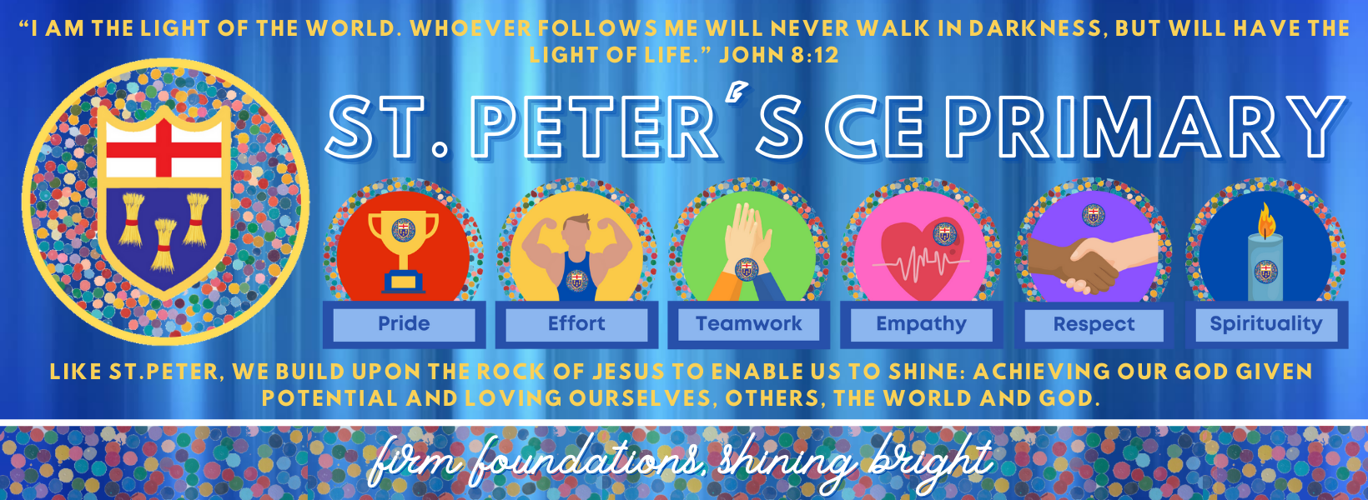

St. Peter’s CE Primary School, Heswall
Instrument of Governance
2025 -26

Date Adopted: 16.09.25
Date of Review: September 2026
Committee: Full Governors

Signed: 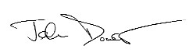(Chair of Governing Body)

INSTRUMENT OF GOVERNMENT

- The name of the school is St Peter’s Church of England Primary School.
- The school is a Voluntary Aided school.
- The name of the governing body is “The Governing Body of St Peter’s Church Of England Primary School.”
- The governing body shall consist of:
7 Foundation governors
1 Headteacher
1 LA Governor
1 Staff governor
2 Parent governors

5. The total number of governors is 12.

6. Foundation Governors, other than the ex-officio Foundation Governor, shall be appointed as follows:-

- 3 Governors by the Chester Diocesan Board of Education

- 3 Governors by (the Chester Diocesan Board of Education in consultation with the Parochial Church Council of Heswall St Peter.)

7. a) The holder of the following office shall be a Foundation Governor ex-officio: the principal officiating minister in the parish of Heswall St. Peter.

b) The Archdeacon of the Archdeaconry in which the school is situated shall be entitled to appoint a Foundation Governor to act in the place of the ex-officio Foundation Governor whose governorship derives from the office named in (a) above, in the event that the ex-officio Governor is unable or unwilling to act as a Foundation Governor, or has been removed from office.

8. The Archdeacon of the Archdeaconry in which the school is situated shall be entitled to request the removal of any ex-officio Foundation Governor and to appoint any substitute Governor.

9. There is a trust for the school.

10. Recognising its historic foundation, the school will preserve and develop its religious character in accordance with the principles of the Church at parish and diocese level. The school aims to serve its community by providing education of the highest quality within the context of Christian belief and practice. It encourages an understanding of the meaning and significance of faith and promotes Christian values through the experience it offers all its pupils.

11. This Instrument of Government comes into effect on 1 September 2015.

12. This Instrument was made by order of Wirral Local Authority on 25th March 2015

