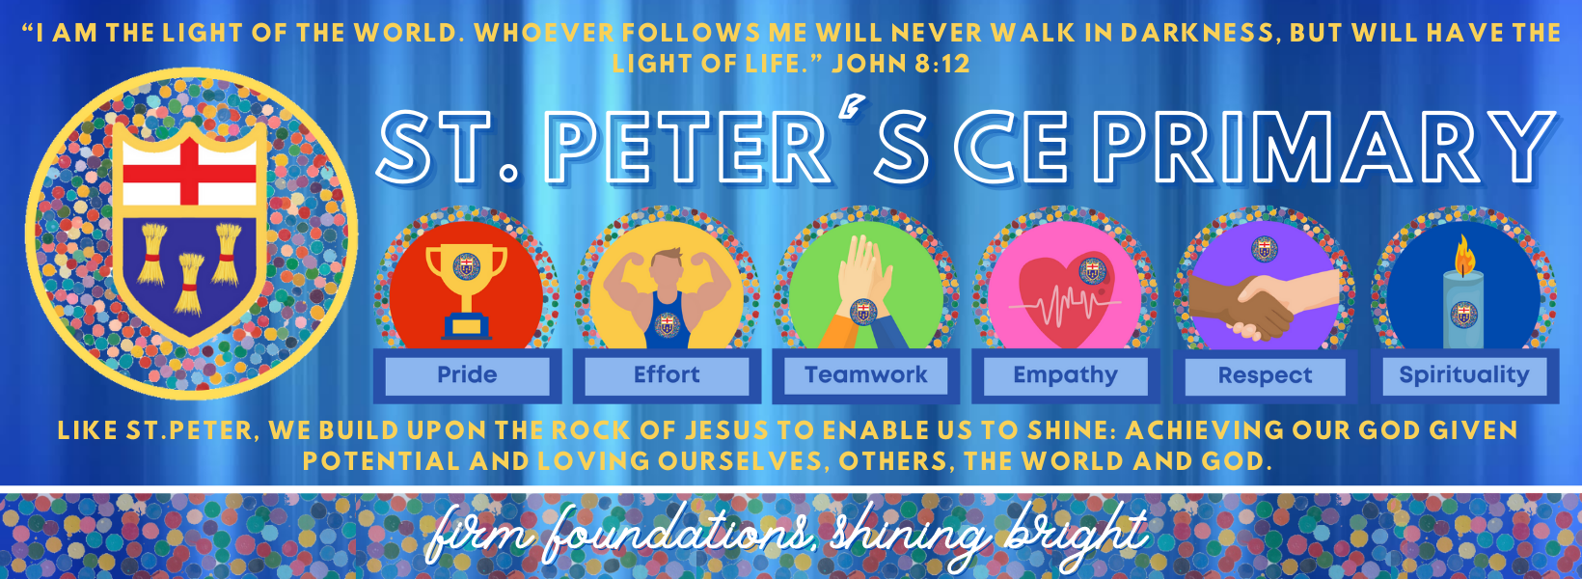

St Peter’s Primary School Heswall
Social Media Policy and Declaration



2026 – 2027

Date Adopted: 23.11.23
Date of Review: June 2026
Committee: Health and Safety
Signed: 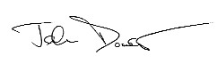

Local Authority Adopted Policy
Social Media Policy and Declaration
The purpose of the policy is to provide clarity to all school staff on the use of any social media. Social media is a broad term for any kind of online platform which enables people to directly interact with each other. However, some games and video sharing platforms have social media elements to them. The principles set out in this policy must be followed irrespective of the electronic medium.
It should be noted that St Peter’s CE Primary School has an active facebook account. This can only be posted on by members of the school staff. As a school the purpoises of our social media account are as follows:
- To provide additional communication to parents
- To celebrate the success of the school with all stakeholders
- To market the school to prospective parents
As part of this we do post pictures of children on facebook as they are at the heart of the school. However, we only post pictures with permission from parents and we do not post full names.
Any member of staff can have an account on social media. However, it is the responsibility of the individual to ensure that anything placed on the social media is appropriate and meets the standards expected of professional teachers and support staff.
It is the responsibility of staff members to remain vigilant and ensure that they regularly review privacy levels of the social media accounts to ensure that they are ‘restricted’, and to protect their own privacy. The does not negate responsibility for the requirements below.
The policy relates to contact with any young person under 19 years of age, any ‘looked after child’ under the age of 21 years of age, and any young person with special educational needs under the age of 24 years of age. NB School employees who have their own social media accounts may have contact with relatives or family friend, but all the requirements below would still apply.
All school staff must:
- Demonstrate honesty and integrity, and uphold public trust and confidence in respect of anything placed on social networking websites.
- Ensure that any content they share on any social networking website, at any time, would be deemed as appropriate, ie staff are personally responsible for ensuring that any privacy setting meet this requirement
- Ensure appropriate language is used at all time, for any comments place on social networking sites
- Ensure that any comments and/or images, at any time, could not be deemed as defamatory or in breach of any relevant legislation
- Decline ‘friend requests’ for pupils and ex-pupils, which they receive in their personal social media accounts (in line with age-restrictions above)
- Notify the headteacher of any malicious postings
All school staff must not:
- Knowingly have personal contact with current or ex-pupils, or other children or young people where is a relationship developed as part of their ‘professional’ role, eg music tutor, on any social media
- Contact parents or carers (or respond to them) on personal social media sites to discuss school issues
- Use social media as a forum to make derogatory comments which could bring the school into disrepute, including making comments about pupils, parents, other staff members, the senior leadership team, governors, local authority or the wider community
- Publish photographs, videos or any other types of images of pupils and their families
- Use personal communication media, eg email or mobile phone, for contact with pupils
I have read the policy on the use of social media and understand that any breaches of this policy could result in disciplinary action and may result in dismissal.
This document has been developed, consulted and collectively agreed with the trade unions and professional associations: ASCL, GMB, NAHT, NASUWT, NEU, UNISON, UNITE.

