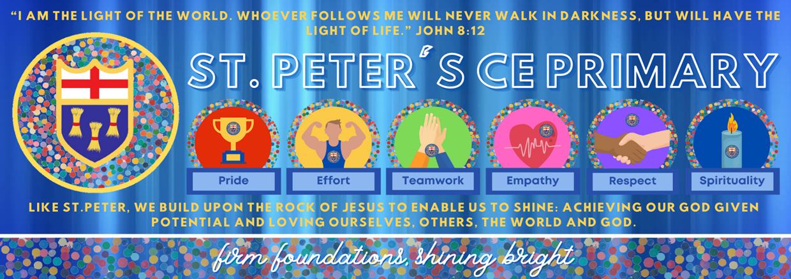

St. Peter’s CE Primary School, Heswall
Spirituality Policy
2026 - 27
Date Adopted:
Date of Review:
Committee: Standards

Signed: (Chair of Governing Body)

The school’s understanding of spirituality

Understanding of spirituality within St Peter’s CE Primary School starts with an acknowledgement of our school context and our theologically rooted Christian vision.
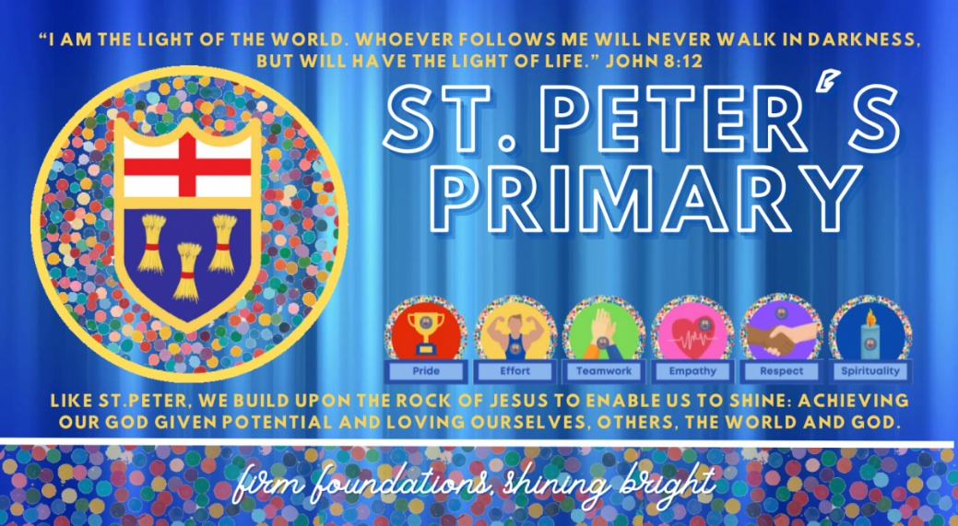
We also consider the Anglican foundation of our school and consider the Biblical response to spirituality.
Our definition of spirituality
As a Church School, spirituality is all about our relationship with God the Father, whom we come to through Jesus his Son, united in the Holy Spirit. We define spirituality as “the deepest values and meanings by which people seek to live.” Our school vision embodies this, placing spirituality at the root of everything we do and is reflected in our vision: Like St Peter, we build upon the rock of Jesus, to enable us to shine, achieving our God-given potential, loving ourselves, others, the world and God. It is the way our fundamental values, lifestyles and spiritual practices reflect our understanding of God, ourselves, others and the world around us. At St Peter’s, we acknowledge spiritual development is not a direct path – it is cyclical, and goes through many phases through all aspects of life.
Rebecca Nye suggests that spirituality can be defined as relational awareness. That means awareness of the relationship with:
- Self (being a unique person and understanding self-perception)
- Others (how empathy, concern, compassion and other values and principles affect relationships)
- World and Beauty (perceiving and relating to the physical and creative world through responses to nature and art)
- Divine (relating to the transcendental and understanding experiences and meaning outside the ‘everyday’)
Galatians 5:22-23: “But the fruit of the Spirit is love, joy, peace, patience, kindness, goodness, faithfulness”.
John 15:1-5 “I am the true vine, and my Father is the vinedresser. Every branch in me that does not bear fruit he takes away, and every branch that does bear fruit he prunes, that it may bear more fruit. Already you are clean because of the word that I have spoken to you. Abide in me, and I in you. As the branch cannot bear fruit by itself, unless it abides in the vine, neither can you, unless you abide in me. I am the vine; you are the branches. Whoever abides in me and I in him, he it is that bears much fruit, for apart from me you can do nothing”.
Matthew 6:25: “Is not life more than food and the body more than clothing?”
These Bible passages offer a helpful starting point in unpacking what spirituality can mean. In the passages above it shows that for Christians, spirituality is about remaining close to God and that developing spirituality is something more than what can be seen and has an impact on a person’s character. However, it must be acknowledged that Church of England Schools are inclusive communities that welcome people of all faiths and none. Spirituality is also something that is deeply personal and can differ greatly between individuals. It is something that may be easily felt but not so easy to define or articulate. However, for a school to develop spirituality in the ways outlined by the OFSTED and SIAMS inspection expectations above, St Peter’s has decided to adopt a shared understanding and language of expression of spirituality so that it is more accessible to every member of our school community.
St Peter’s understands spiritual development as relating to seven concepts:
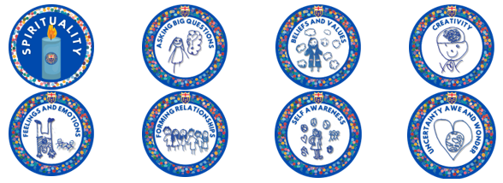
St Peter’s has decided to use the following language of expression to talk about the four concepts above.
Windows, mirrors and doors

This concept was outlined by Liz Mills in the ‘Interpretations of spirituality’ publication by the church of England (October 2019). This creates a concrete way of exploring the four main areas of spirituality with pupils. The visual of a ‘window’ creates opportunities for pupils to look out at the world, other people around us, just as we would look out of a window. We can learn and reflect on what we observe around us. A ‘mirror moment’ gives opportunity to reflect on self (just as you look at yourself in a mirror) and prompts pupils to think about their own thoughts, beliefs and ideas. The ‘door’ gives pupils an opportunity to think about their impact on the world and what could be done or thought further about in response to the ‘window’ and ‘mirror’ moments. As the 2019 publication above states, ‘door moments’ give an opportunity for:
“moving on, making choices, and doing something creative, active and purposeful in response. This can simply be done through a change in attitude or behaviour or thinking. It can also be expressed powerfully through music or art or drama or dance and through some form of social action or specific acts of giving”.
Please not that the exploration of ‘beyond’ could be realised through any of the ‘window’, ‘mirror’ or ‘door’ moments above.

Organisation
The responsibility of spiritual development in St Peter’s is shared across the whole school community. The oversight of spirituality within St Peter’s sits with Dave Wallace (Headteacher) They support the development of spirituality within St Peter’s by ensuring that all new staff are aware of our school’s shared understanding of spirituality, ensuring they are up to date with information and training on spirituality from Chester Diocesan Board of Education, the Church of England and the department for Education. They also create opportunities for staff to share ideas and best practice as well as have an oversight of monitoring and evaluation of spiritual development and contribute to the SIAMS self-evaluation process, particularly around Inspection question 2 and 3.
As a school, we acknowledge the importance of planned and unplanned opportunities for spiritual development within school and encourage our staff to identify areas within the curriculum that spirituality can be realised, as well as to take advantage of moments that may occur in school ad hoc. The areas listed below is where staff have planned for spiritual development and unplanned moments may occur in the leaning in of stories or ideas that pupils want to share, an appreciation of ‘awe and wonder’ moments that may occur in and outside of school and/or ‘ow’, ‘wow’ and ‘now’ moments.
- Collective Worship
- Religious Education
- Personal development / PSHE
- Opportunities across all curriculum areas
Planned opportunities for spiritual development
Spirituality in Collective Worship
Daily Collective Worship is the beating heart of (insert name of school). It provides the opportunity for our school community to come together to hear the Christian story, learn about Christian festivals, celebrations of other faiths and to share experiences, beliefs and ideas. The shared spiritual language of (insert the language you have decided upon) is referred to explicitly within Collective Worship. The information below states how (insert name of school) develops spirituality and enables spiritual flourishing within Collective Worship across the seven main areas of spirituality.
- Asking Big Questions – Pupils and staff are presented with a Christian worldview as well as other religious worldviews at appropriate times in the year and other local and world events that occur throughout the academic year.
- Beliefs and Values – Pupils and staff are encouraged to discuss their ideas and beliefs with one another and listen to the views of others that are shared within Collective Worship.
- Creativity – Pupils have the invitational opportunity to relate to God through prayer, singing and reflection.
- Feeling and Emotions –
- Forming Relationships –
- Self Awareness – Pupils and staff are given meaningful opportunities to reflect on their own beliefs and ideas in response to the distinctively Christian message or concept that is offered. They are given opportunities to share these ideas and express their unique identities through a range of mediums such as reading, acting, singing and dancing.
- Uncertainty, Awe and Wonder -
Spirituality in Religious Education
The Church of England’s Statement of Entitlement (2019) outlines the aims and expectations for Religious Education in Church of England Schools and guides this school’s approach to RE and spirituality. The information below states how (insert name of school) develops spirituality within Religious Education across the four main areas of spirituality.
- Asking Big Questions –
- Beliefs and Values – Pupils have opportunities to share their own views and listen to the viewpoint of others within the classroom.
- Creativity –
- Feeling and Emotions –
- Forming Relationships –
- Self Awareness – personal knowledge within RE is a student's individual understanding of religions and non-religious worldviews, shaped by their own life experiences, values, and beliefs. Pupils are given opportunities to become aware and reflect upon their own assumptions, viewpoints and positions on different topics within RE.
- Uncertainty, Awe and Wonder -

Recording, Monitoring and Evaluation
The development of spirituality is monitored and evaluated routinely as part of the school’s self-evaluation process. This is done in the following ways:
• Reviewing how Collective Worship enables spiritual flourishing by observing different examples of Collective Worship in school
• Conducting pupil/staff/parent voice on spiritual development within school
• Reviewing the use and impact of spiritual / prayer / reflective spaces in school
• Meeting with the CW and RE lead as well as leads from other curriculum areas to discuss opportunities for spirituality across the curriculum.
• Learning walks on a frequent basis to see if planned opportunities for spirituality are being lived out across the curriculum.
Governors ensure that this policy is fully implemented and that practice is consistent with the school’s Christian vision, in line with the school’s monitoring policy and schedule for governors.
This policy is shared on the school’s website and is part of the induction pack for new staff and new governors.
This policy is reviewed every 3 years, or more frequently, as required.

