Spirituality Across the Curriculum at St Peter’s
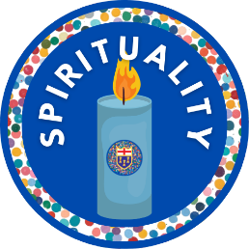 |  | 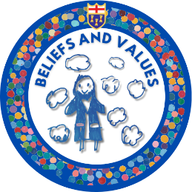 | 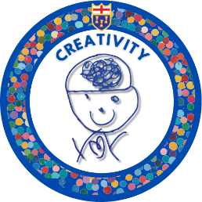
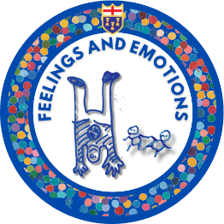 | 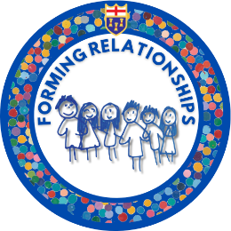 | 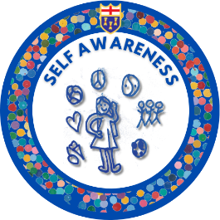 | 

Where pupils flourish beyond the National Curriculum objectives
Opportunities to develop spiritually at St Peter’s
We provide rich opportunity for our children to develop spiritually within our curriculum.

Physical Education
- By delighting in movement, particularly when pupils are able to show spontaneity.
- By taking part in activities such as dance, games and gymnastics which help pupils to become more focused, connected and creative.
- By being aware of one’s own strengths and limitations.

Computing
- By wondering at the power of the digital age e.g. use of the internet and social media.
- By understanding the advantages and limitations of modern technology.
- By using the internet as a gateway to big life issues.

English
- By allowing for insight, self-expression and the chance to walk in someone else’s shoes and consider other viewpoints
- By writing creatively, embracing our own skills and imagination, understanding of words and language
- By exploring texts and stories that challenge our perspectives and express ‘big ideas’ about life and ethical issues

Music
- By allowing pupils to show their delight and curiosity in creating their own sounds.
- By considering how music makes one feel and can ‘move us’ deeply.
- By understanding the way artists communicate their feelings through their music

Art and Design Technology
- By enjoying and celebrating personal creativity and reviewing and evaluating created things.
- By exploring different artists’ interpretations of a key figure or event and asking what the artist was trying to convey.
- By allowing pupils to show what they know through their own expression of big ideas about life and the world around them

PSHE/RSHE
- By developing awareness of and responding to others’ needs and wants.
- By exploring meaning and purpose for individuals and society.
- By developing resilience and inner strength.
- By valuing self as unique in the image of God.
- By cherishing relationships.

Religious Education
- By experiencing wonder and joy through learning about and from stories, celebrations, rituals and different expressions of religion and worldviews.
- By asking and responding to questions of meaning and purpose.
- By considering questions about God and evaluating truth claims.
- By exploring spiritual practices such as worship and prayer, and considering the impact of these on believers as well as relevance to their own life.
- By developing our own beliefs

Geography
- By using maps and asking pupils to imagine what it might be like to live in different parts of the world and comparing their lives with others.
- By making links with history when exploring the environment and speculating on why the landscape has developed in a certain way, and human impact upon this.
- By exploring the awe and wonder of the natural world

History
- By considering how things would be different if the course of events had been different
- By looking at local history and investigating the reasons why our community developed in a certain way
- By considering how we mark important events from history and the people who shaped them.

MFL
- By exploring the beauty of languages from around the world.
- By exploring the way language is constructed.
- By developing an understanding of the language of others.

Science
- By demonstrating openness to the fact that some answers cannot be provided by Science.
- By creating opportunities for pupils to ask questions about how living things rely on and contribute to their environment
- By experiencing awe and wonder of the natural world and the diverse individuals who contributed to the field of science.

Maths
- By developing resilience and perseverance in the face of challenge
- By reasoning and solving problems, understanding other points of view or approaches
- By developing an appreciation of the intangible and abstract

In experiencing life and learning at St Peter’s, Pupils become aware of the world, connect with it and respond and reflect upon their learning expressively (whether planned or unplanned) leading to spiritual development.

A personal spirituality
In considering the spiritual development of each person, we explore opportunities to meet a range of dominant spiritual temperaments; delivering opportunities where enjoyment, curiosity, fascination about the world, enquiry, imagination and creativity are always a priority, utilising our abundant school grounds and local area, and ultimately provide opportunities for our pupils to glimpse a deeper reality.

