St Peter’s CE Primary School
A Curriculum for Living Life in All It’s Fullness
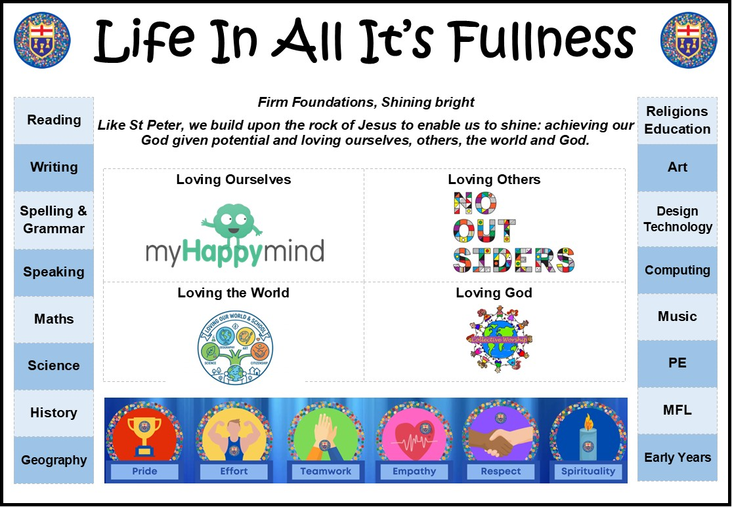
Vision Statement

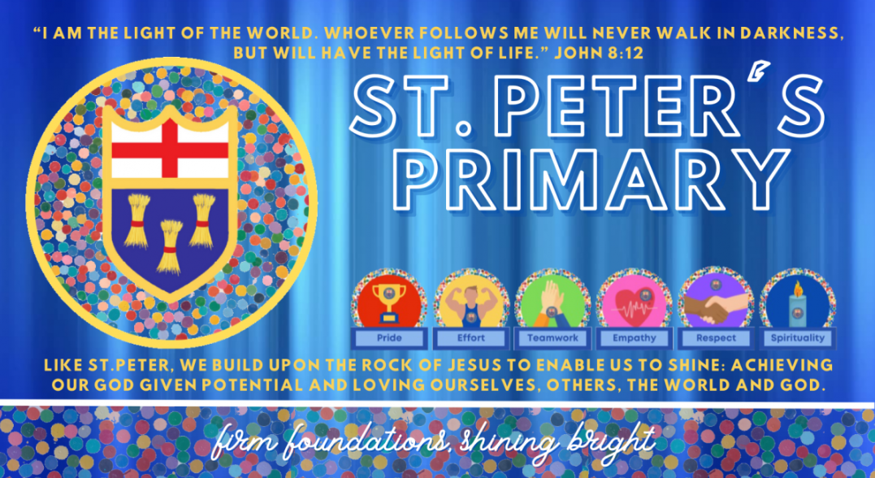
Our motto, ‘Firm Foundations, Shining Bright’, resonates throughout school and in our partnership with our families and wider community. Through our stimulating curriculum, our aim is to provide opportunities for all children to foster a love of learning and be successful and reflective learners. When selecting our programmes of study, we strive to provide a broad and balanced curriculum for our children that has clear progression of knowledge, skills and abilities throughout each key stage and their whole journey through school. This is inclusive of local, national and international issues which enable children to develop the courage to be respectful individuals that make reasoned, positive, unbiased and informed choices.
A full explanation of our school vision can be found here.
https://www.youtube.com/watch?v=D5WQeRGrawU
Life in All It’s Fullness
At St Peter’s, we aim for all children to experience the life in all it’s fullness that Jesus offers by:
1. Building firm foundations for Wisdom, Knowledge and Skills
Enabling discipline, confidence, and delight in seeking wisdom and knowledge, and developing talents in all areas of life.
- Providing teaching and learning of the highest quality which results in pupils attaining to the full extent of their potential.
- Ensuring that all pupils benefit from a rich, broad, balanced curriculum presented in an interesting, exciting and imaginative manner with lots of opportunities for first-hand experience, practical work, investigation and learning through play.
- Enriching the curriculum with visits, visitors, and extensive use of our unique environment.

2. Building firm foundations for Hope and Aspiration
Enabling healing, repair and renewal, coping wisely with things and people going wrong, opening horizons and guiding people into ways of fulfilling them.
- Treating pupils as individuals and to differentiate teaching and learning to take account of their individual and special needs demonstrating a clear awareness of children’s preferred learning styles.
- Match teaching and learning to the appropriate stage of children’s physical, mental, social, spiritual, moral and cultural development needs.
- Helping all children to become more effective and independent learners and leaders within their community.

3. Building firm foundations for Community and Living Well Together
A core focus on relationships, participation in communities and the qualities of character that enable people to flourish together
- Promoting an open, honest and trusting home-school relationship, which is invaluable for a child’s education.
- Building a welcoming, lively, secure community where good behaviour is expected and where they can acquire the leadership skills relevant to adult life and employment in a fast changing world.

4. Building firm foundations for Dignity and Respect
The basic principle of respect for the value and preciousness of each person, treating each person as a unique individual of inherent worth.
- Instilling a respect for Christian and moral values and principles, whilst engendering respect and understanding of other beliefs: fostering Christian values so that all children have respect for themselves, others and the environment.
- Providing a caring, happy and stimulating environment in which children are highly motivated in a non-threatening atmosphere.
- Being an inclusive school that celebrates diversity and ensures that all pupils are given equality of opportunity regardless of gender, special needs, disability or race.
Building firm foundations across the curriculum will use the following elements:
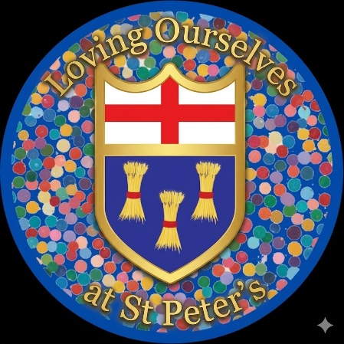 | 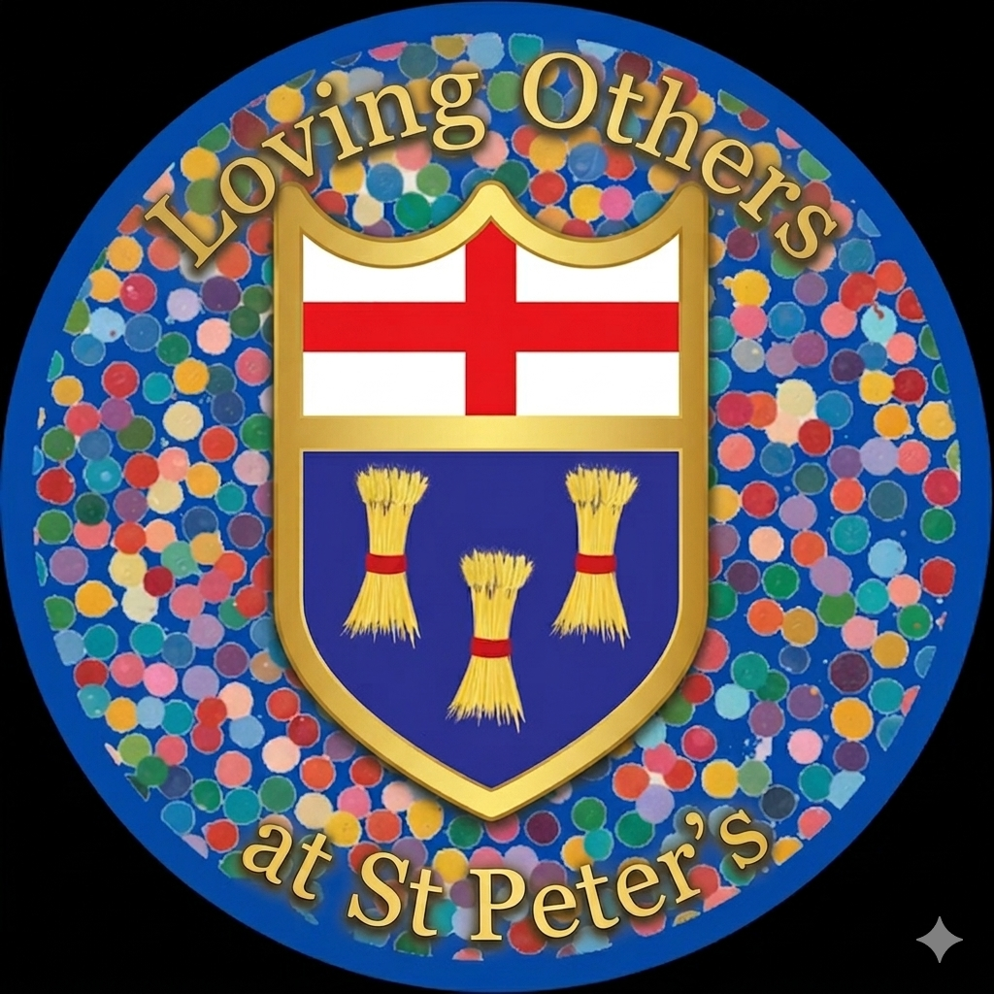
Our worships, RSE and PSHE lessons teach us that we are uniquely and wonderfully made by God drawing on the verse from Psalm 139.  ‘I praise you because I am fearfully and wonderfully made;’ | We love our neighbour by firmly basing how we treat others on the parable of The Good Samaritan. In school we embrace the No Outsiders ethos, again referencing the Good Samaritan and the Church of England guidance for valuing all God’s children.  We teach about diversity to ensure that all children leave St Oswald’s prepared for life in modern Britain.
 | 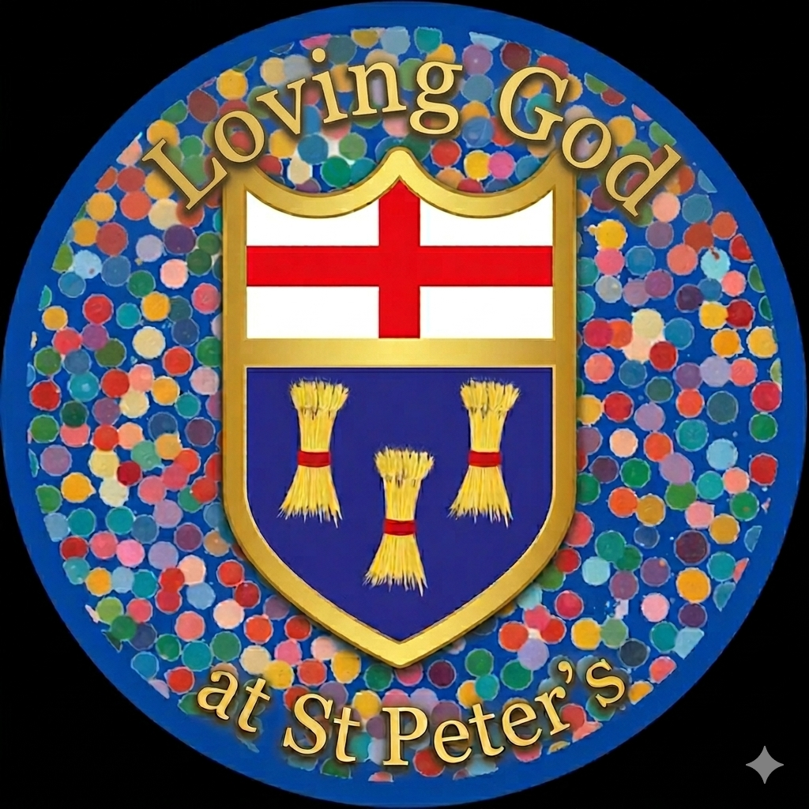
Through our collective worship and science and geography curriculums in particular we learn to love the world that has been made for us. | We show our love for God by trying to live and work in his image following and demonstrating our PETERS school values.  

Our PETERS values are the golden threads that weave their way through our stimulating and engaging curriculum; staff and children alike, regularly refer to our core beliefs in lessons. Reflecting upon attitudes to learning, demonstrating exemplary conduct around our school and ensuring well being for all members of our school community, our PETERS values enable all to achieve their full potential.
Value | Biblical Reference
 | 
 | 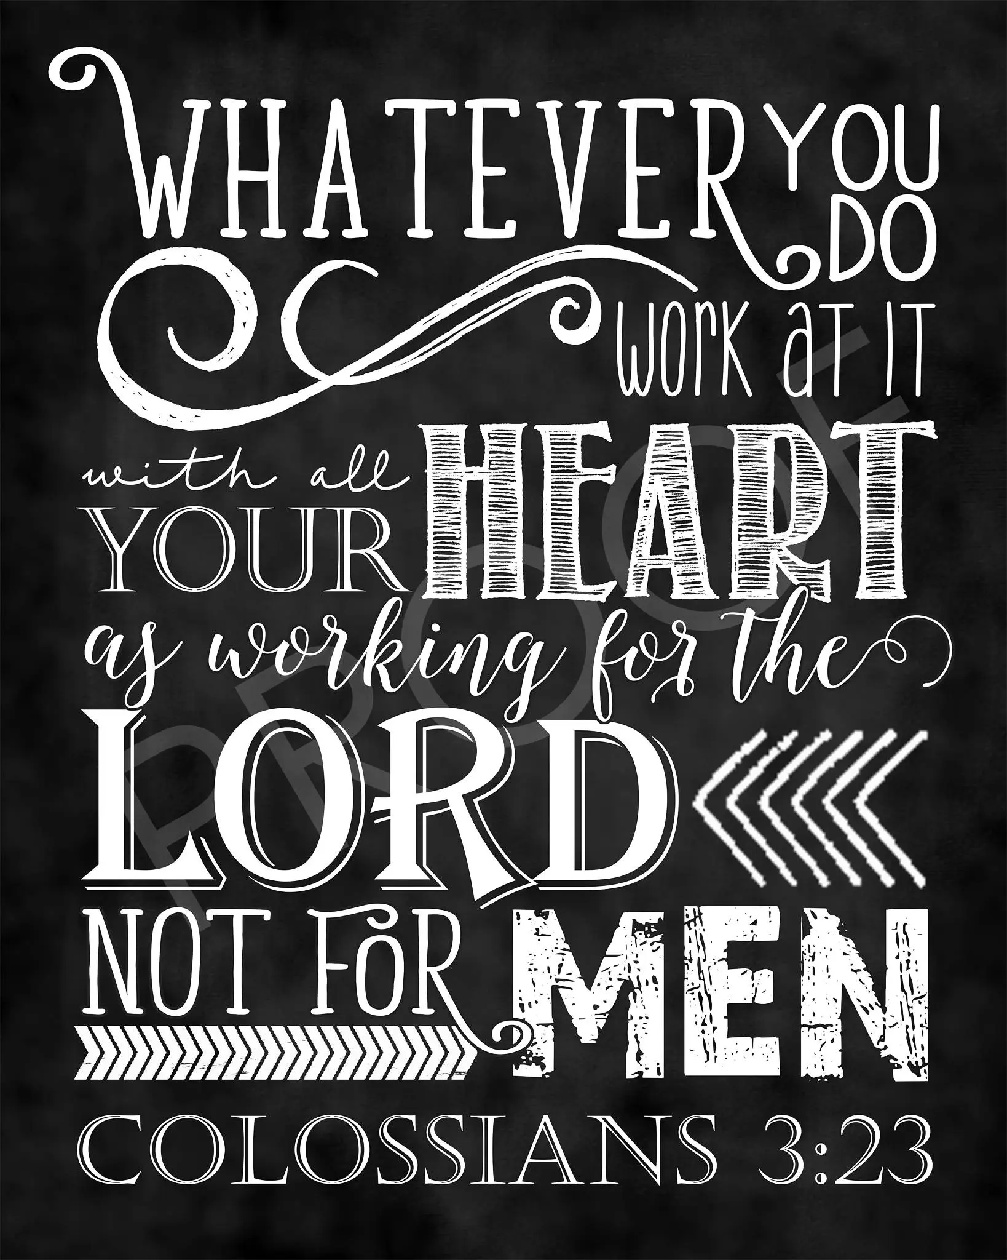
 | 
 | 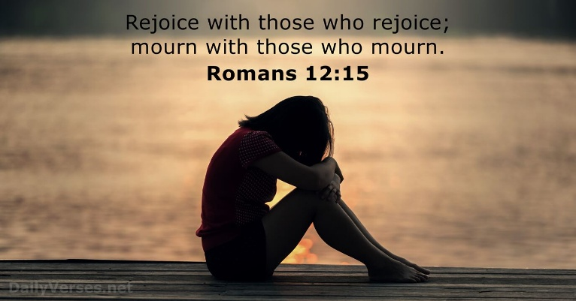
 | 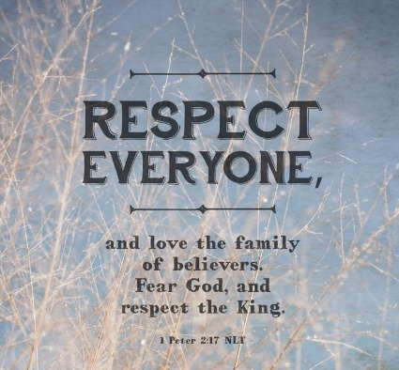
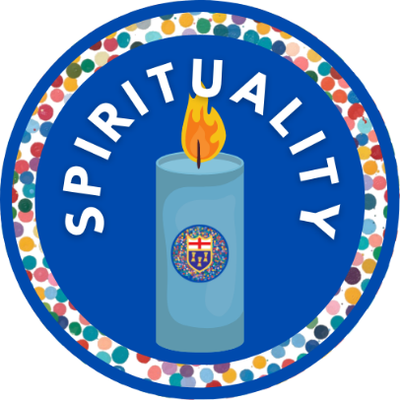 | 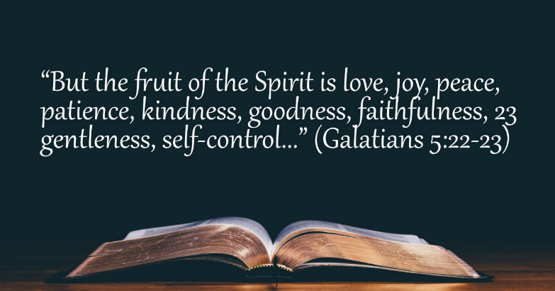

Through our Christian Vision, our curriculum intent, first quality teaching, appropriate interventions where needed and the content outlined in this document we aim at St Peter’s to provide a curriculum for living

Life in All It’s Fullness

