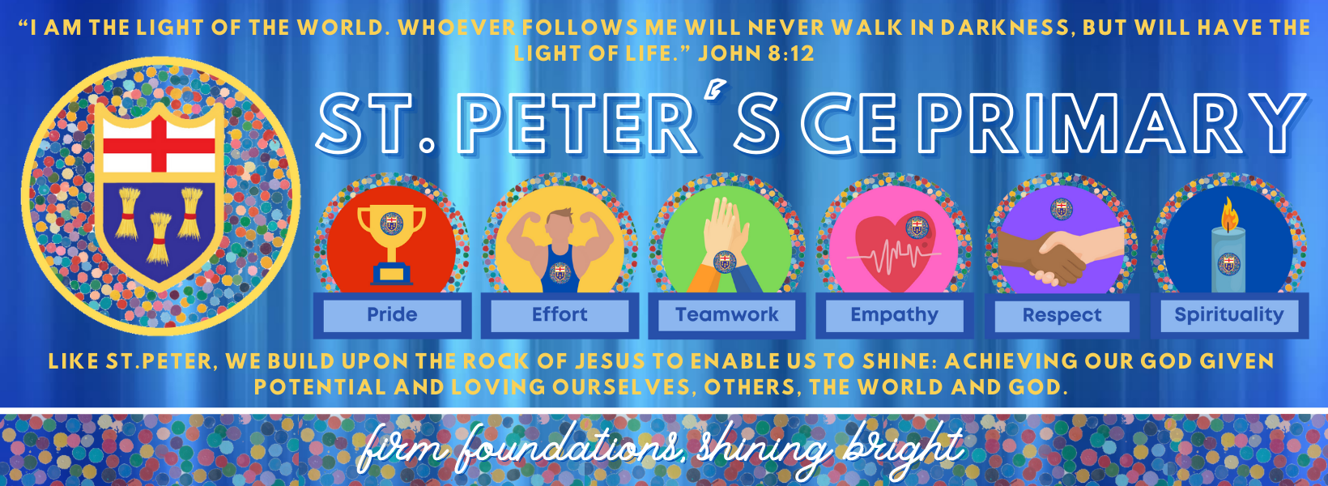

**St. Peter’s CE Primary School, Heswall**

**Policy**

**2024 -25**

**Date Adopted:**

**Date of Review:**

**Committee: Full Governors**

This document is written in the light of our VISION STATEMENT, and the content reflects the aims of the school.

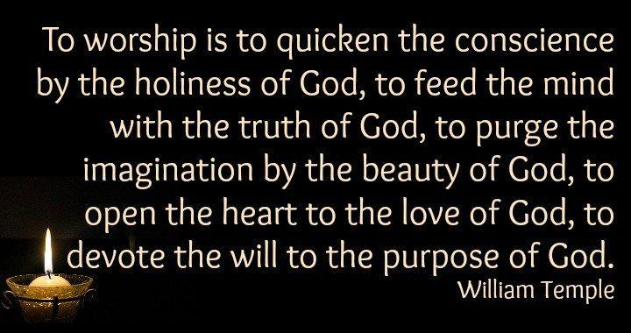

**1.1 Introduction**

St Peter’s Church of England Aided Primary School is an Anglican School and the religious education it provides conforms with the rites, practices and doctrines of the Church of England. These provide the foundations which are the central focus for the ethos of our School.

This policy has been prepared by the governors and headteacher with assistance from the RE leaders. Diocesan guidelines for collective worship have been referred to.

**1.2 The right of withdrawal**

The parents’ legal right to withdraw their child from acts of worship is clearly laid out in the school prospectus. We acknowledge the parents’ right to withdraw their children, but do make clear in our prospectus that the Act of Worship is central to the life of the School and is not an occasion for evangelism.

If there are any children whose parents exercise their right to withdraw them from worship, alternative activities will be provided in consultation with the children’s parents. This does not mean that the children will be in any way exempt from the Christian ethos of the school which underpins the whole of school life. Parents are made fully aware of this when they enrol their children.

**2 Aims and Objectives**

St Peter’s CE (Aided) Primary School is committed to offering high quality collective worship. We recognise and value collective worship as central to fostering a sense of community and to expressing our Christian vision. The School family are helped to understand the meaning of Christian worship and we hope that believers will be able to share in it and that others of no faith will reach the 'threshold of worship'. In practice this means that structure, planning, evaluation, participation and collaboration of worship are all taken seriously by the school.

The Church of England Vision for Education ‘Deeply Christian, Serving the Common Good’ states: ***We want pupils to leave school with a rich experience and understanding of Christianity, and we are committed to offering them an encounter with Jesus Christ and with Christian faith and practice in a way that enhances their lives...Collective worship in schools, including prayer, reading and reflecting on the Bible, liturgy, sacrament and experience of the musical and other imaginative riches of Christianity, provide a vital opportunity for this. (p.10).***

At St Peter’s CE Primary School collective worship is integral to the daily life of our school community. Collective worship strengthens and supports the Christian distinctiveness of our school, reaffirms our values and celebrates the contributions of every adult and child. The daily act of Christian worship underpins our vision and is supported by all children, staff and governors. The school has a strong partnership with St Peter’s Church who we collaborate with to strengthen the provision of our school.

Worship is central to realising our vision: **‘Like St Peter, we build upon the rock of Jesus to enable us to shine: achieving our God given potential, and loving ourselves, others, the world and God.’**  
  
Worship is a time where we come together to learn about the **‘firm foundations’** and to celebrate by **‘shining bright’**.

The worship of the school is based on promoting the **PETERS** **values**;



These permeate the ethos of the school. As such, Worship is an essential part of the school day and the contributions of staff, pupils, clergy and other visitors are valued highly.

**Our central aims of collective worship (as detailed in the Diocesan guideline) are to:**

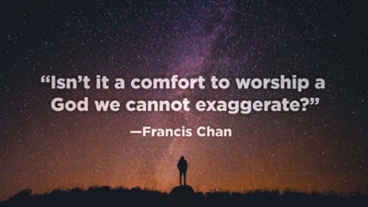

• enable children and staff to explore and celebrate the differences and diversity found in the variety of forms of worship in the Anglican Christian tradition.

• lead the school community to the ‘threshold of worship’ in order for them to make an informed choice about their own involvement and to consider their own personal relationship with Jesus Christ.

• seek to deepen and widen the experience of those of ‘faith’ and encourage those of ‘no faith’ so that they begin to feel for themselves something of what it means to worship. 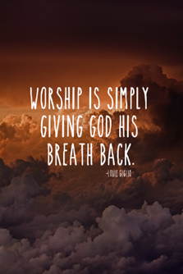

• use celebration, silence, stilling, reflection, contemplation, meditation, prayer, song, symbols and imagery as vehicles for worship and spiritual growth.

• provide opportunities for the whole school community to address God directly through Jesus in the power of the Holy Spirit through acknowledging his presence, reflecting upon his character and giving Him praise and honour.

• use a vocabulary of worship that encourages the whole school community to attend, participate and lead worship.

• encourage all present to explore their own beliefs and understanding of God within a Christian framework by learning more about the Christian faith and by encountering Christ through worship.

• raise awareness through reflection of the ultimate questions of life relating to matters of faith.

• reaffirm, strengthen and practise key Christian values. (e.g. love, peace, compassion, forgiveness, self giving) and celebrate each unique individual member of the school community as made in the image of God.

• nurture and encourage respect and care for God's created world by promoting a positive attitude to environmental issues locally, nationally and globally.

• seek to provide opportunities for spiritual, social and moral development that is characterised by feelings such as awe, wonder, being uplifted, elation, appreciation, gratitude, respect, and reverence.

• develop a sense of community within the school, the locality, (e.g. local church) and foster the sense of being part of a wider community though the celebration of achievements, festivals and special occasions. 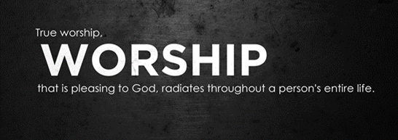

• foster a concern for the needs of others.

**In summary, within our daily act of collective worship, we aim to provide opportunities for children to:**

• provide an opportunity for children to worship God;

• celebrate all that is good and beautiful and express thankfulness for the joy of being alive;

• provide opportunities for children to share what is meaningful and significant to them, including the darker side of life;

• ensure that the experiences provided are relevant to the age, aptitude and family background of the children;

• give time for silent reflection and exploration of inner space;

• illustrate forms of worship that others have found helpful in their spiritual development, e.g. silent contemplation, dance, singing;

• provide a rich variety of forms of expression, e.g. art, drama, music, story and give children the opportunity to experience these at their own level rather than teachers imposing their own interpretations;

• take place in an environment that is conducive to worship, which is professionally coordinated and properly resourced;

• always invite, never coerce, remembering that children will be at different stages of spiritual development and that they should feel able to respond and participate at their own level.

(National Society website, 2007)

At St Peter’s we aim for Collective Worship to be the following for **ALL** who take part:

| **How?** | **Inclusive** | **Invitational** | **Inspirational** |
| --- | --- | --- | --- |
| Use of inclusive phrases for use when introducing prayer or reflection might be: ‘Now a chance to think about’, ‘You can use this as a time of prayer’, or ‘Something to think or pray about’, ‘Take away’, ‘If you agree with this prayer you can join me in saying Amen at the end’.  By valuing and celebrating differences and diversity  By delivering a message which is memorable, yet at the same time readily comprehensible by people of with less religious vocabulary.  By providing an opportunity to reflect or express own responses. Opportunities for all to participate e.g. lighting the candle, saying prayers etc | Different methods and responses to prayer  music, silence, reflection, active, pictures, art, illustrations  answering questions, being involved in role play, or working with props.  Opportunities to express own responses. | Help children understand that God is a God of comfort.  Give back to God- recognising all we have from God and all he is. Explore with the children how worship can become a way of life. It’s not just about a daily session. Provide a space for children to ‘get personal with God’ not just learn about God  Reflect on the lives if inspirational Christians and characters from the bible |

At St Peter’s C.E. Aided Primary School, assembly is understood to be the coming together to share a common purpose (e.g celebration of achievement, good social behaviour - reinforcing community/social values, dissemination of information about a forthcoming event).

Worship, however, is when we meet to acknowledge and reflect in God, beyond and in us all. It is where we acknowledge an infinitely larger world we inhabit and where we are touched, however fleetingly, by its mystery and wonder.

Our daily collective meetings can involve the two elements but are quite distinctive.

**3 Planning**

We hold acts of worship everyday which take place in classrooms, in the hall, outside, and at St Peter’s Church Backford. All worships may follow liturgical structure, including the Holy Trinity. Christian festivals are celebrated by the school community during services in the school hall or at St Peter’s Church Backford.

Worship usually takes place in the hall. Children are expected to enter quietly and respectfully and listen to or join in with the worship song that is playing on the big screen.

* **Monday** – Whole School Worship  
  This is led by St Peter’s church and use the Big Start Assemblies materials.
* **Tuesday** – Headteacher Worship   
  This is led by Mr Wallace and focuses on different series of worships as well as one offs. Recent themes have been ‘St Peter’, ‘Our School Vision’ and ‘The Big Story’.
* **Wednesday** – Come and Praise  
  This is led by Miss Collins and involves learning and singing praise and worship songs.
* **Thursday or Tuesday** – Class Worship  
  This worship is led by class teachers. This year it is focusing on Picture news and topical events.
* **Friday** – Celebration Worship

Awards are given for achievement inside and outside the school which focus on the Peter’s values. This worship is led by year 6 children.

* The act of Collective Worship should lasta approximately 15 minutes and is held separately from notices
* Worship usually follows the structure; gathering, engaging, responding and sending
* Visitors are regularly invited to lead one of our acts of Collective Worship
* Worship lead children help to evaluate worship by observing worships and recording pupil voice
* Children from across the school help deliver worship throughout the year e.g. leading prayer and sharing reflections
* The Church’s calendar is observed - Harvest, Advent, Christmas, Lent, Easter, Pentecost and Saints Days
* The Eucharist is celebrated and taught through Collective Worship.
* Children appreciate music on entry/ exit to Collective Worship which creates an atmosphere of reverence, praise, celebration, stillness and reflection
* Stories and teachings from the Bible are used to explore Christian values. Moral teachings and contemporary events are used when appropriate but these are always linked back to biblical principles through specific bible stories or verses.
* Collects and prayers from Common Worship are used as a focus for Collective Worship including the Lord’s Prayer and the Grace
* Anglican responses e.g. The Lord is here/ *His Spirit is with us*; Peace be with you/ *and also with you*; Go in peace to love and serve the Lord/ *In the name of Christ, Amen* are used

The first collective worship and first afternoon of each half term are focussed on one of our PETERS values. This is a key aspect of the Christian distinctiveness of St Peters.

Over a three year cycle, the Big Start assemblies reflect some of the essential features of the tradition of Anglican prayer and worship. They should nurture spiritual growth through the evolvement of senses, such as those of beauty, awe, wonder, pity, peace, greatness and smallness, and of feelings, such as pride, sadness, thankfulness, joy and happiness.

Staff are aware of their responsibilities for planning, organising and resourcing class and staff led collective worship.

The PETERS values afternoons, and linked to the first collective worship of each term, are as follows.

Autumn 1: PRIDE

Autumn 2: EFFORT

Spring 1: TEAMWORK

Spring 2: EMPATHY

Summer 1: RESPECT

Summer 2: SPIRITUALITY

Pupils will be involved in worship as a School, as a key stage, as a class or as individuals through listening or taking part in contributing to the Act of Collective Worship. Our daily Acts of Collective Worship reflect these spiritual dimensions.

Aided Schools may also hold their Act of Worship in a church “on a special occasion” *(1998 Education act 6 (5)).* Collective Worship usually takes place in the School Hall but may occasionally be organised in classrooms. Special services are held at St Peter’s Church, Heswall. The dates of these are shown on the plans for Collective Worship. They may take place at Christmas (Carol Service led by Y5/6), Ash Wednesday, Mothering Sunday, Easter and at the end of the school year for the Leavers’ Service. The assemblies are maintained in a central space on the school server.

**4.1 Structure of Collective Worship**

Collective Worship (except for Come & Praise) should follow a similar format using the 4 stages of worship as follows:

Gathering

Engaging

Responding

Sending

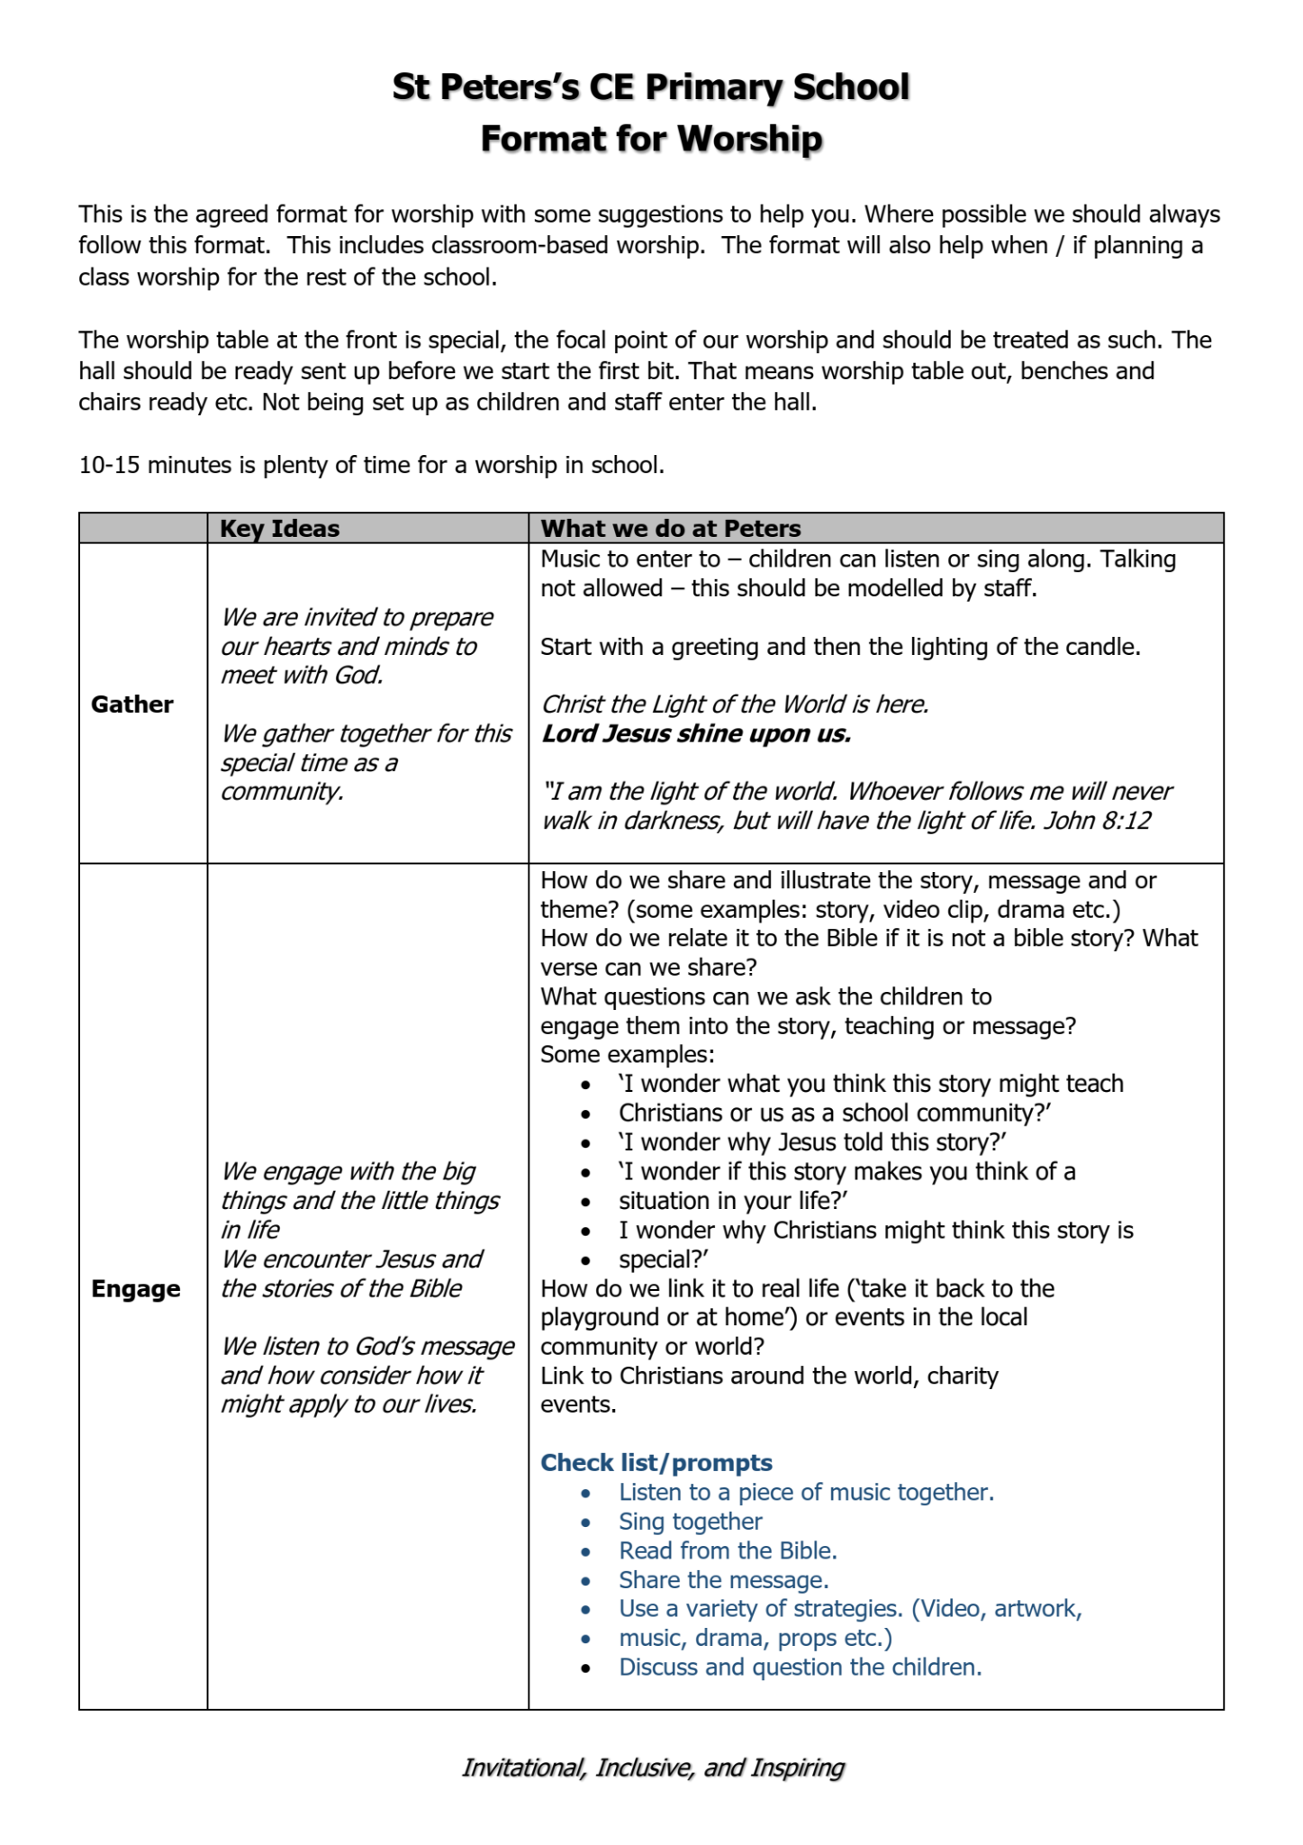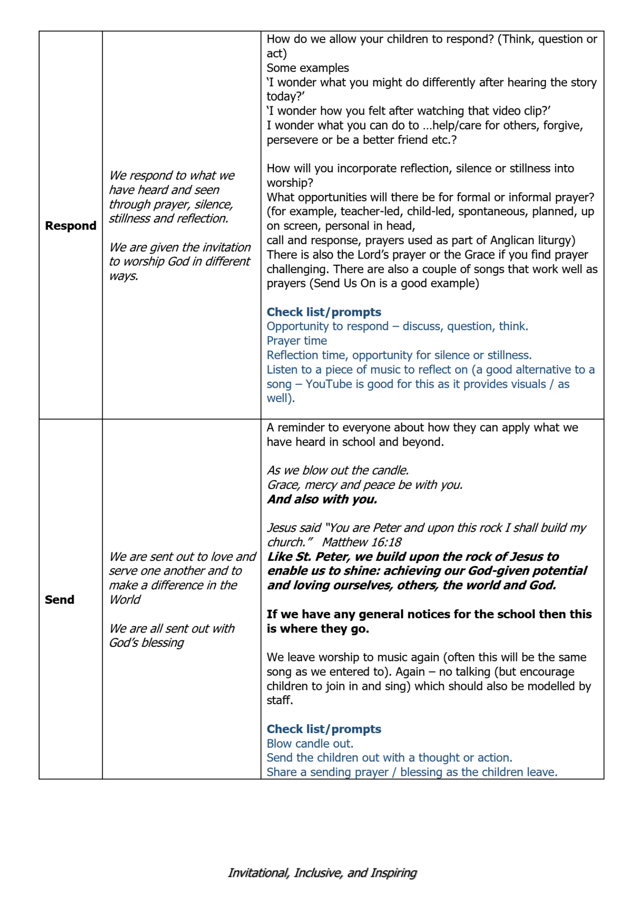

**4.2 Elements of Collective Worship**

Each act of collective worship will include more than one of the following elements:

• celebration of the major festivals of Christianity and of other faiths;

• presentation of Bible stories;

• topical matters from the news or the locality;

• using literature with implicit or explicit religious teaching;

• appreciation of the natural world and human activity;

• appreciation of the talents, achievements and work of ourselves and others;

• visitors who represent organisations who have a brief acceptable to the school;

• prayer in different forms - formal, children’s own, silence and meditation. These might include praise, seeking forgiveness, asking on behalf of self and others and quiet reflection;

• use of music (this will include CDs, singing and instrumental playing by members of the school), drama etc;

• use of appropriate artefacts and focal points (candle, cross, flowers etc.)

• participation by the children and staff;

• using collects, responses, hymns and psalms as a focus for short acts of worship.

(Adapted from the Carlisle Diocesan Collective Worship Guidelines

**5 Monitoring, Evaluation and Review**

Monitoring and evaluation are part of a whole school cycle of self-review and this will be achieved over time by asking all stakeholders to reflect on school worship.

**5.1 Monitoring**

Monitoring of collective worship will be carried out jointly by the headteacher and the RE leaders, with input from the pupils and the wider school community. Strategies for collecting the evidence will include:

* written observations; checking that practice matches planning
* self-evaluation from the children to share their experiences and viewpoints throughout collective worship
* other adult stakeholders evaluating collective worship
* observing children’s attentiveness and level of interest
* seeking feedback from children, staff, parents, governors, incumbent and visitors
* observing the extent of the collective worship’s influence on children’s attitudes and behaviour throughout the school
* holding regular discussions with colleagues

Feedback on evaluations of Collective Worship will be shared with staff and incorporated as part of a periodic review of collective worship.

**5.2 Evaluation**

The information gathered via one or more of the strategies listed above will be analysed carefully in order to evaluate the quality and effectiveness of the collective worship. The headteacher, RE leader and foundation governor(s), including the incumbent, will be the main evaluators. Formal evaluation of collective worship will take place at least annually as part of the RE audit carried out by the RE leader in conjunction with the Ethos group.

**5.3 Review**

The headteacher, governors and staff will review this policy every three years. A worship planning and record sheet is kept weekly to ensure that acts of worship are generally compatible with the requirements of the policy and to inform our learning and planning of further developments.

These will regularly include any formal and informal evaluations of acts of collective worship which will assist monitoring, future planning and delivery. Visitors outside the school community who are regularly involved in acts of worship are provided with a copy of the collective worship policy.

**6 Inclusion and Equal Opportunities**

A daily act of collective worship is held for all children regardless of their background of culture or religion. Every effort is made by the school to involve all children unless withdrawn by their parents in accordance with the law. The following extract from our school’s ‘Equality Policy ‘is relevant to collective worship,

*We are committed to ensuring equality of education and opportunity for all pupils, staff, parents and carers receiving services from the school, irrespective of race, gender, disability, religion or belief, or socio-economic background or any protected characteristics. We aim to develop a culture of inclusion and diversity in which all those connected to the school feel proud of their identity and able to participate fully in school life.*

**7 Responsibilities**

It is the ultimate responsibility of the headteacher and governing body of a school to ensure a daily act of collective worship takes place. At St. Peter’s CE Primary School the co-ordination of the acts of worship is the responsibility of the headteacher. He plans themes, invites and liaises with visiting speakers. A record of the content of each act of collective worship is maintained. Monitoring and evaluation is the responsibility of RE leader and forms part of the audit at least annually.

All teachers at St Peter’s CE Primary School play a vital role in the moral and spiritual development of pupils, and the crucial contribution that it makes to the ethos of the School. Staff attend Collective Worship each day. Class teachers are responsible for organising, planning and resourcing their individual class Collective Worship.

**8 Health and Safety and Well-being**

In collective worship we follow the school’s health, safety and well-being policy. Appropriate care must be taken when using electrical equipment. We now only use battery powered candles. Any internet resources used must be checked carefully by the worship leader, prior to their use in act of collective worship. In the event of fire all pupils must be familiar with exit routes from the halls and other areas of the school where collective worship takes place. Similarly, pupils must be familiar with exit routes from St Peter’s Church. Visitors are not left unaccompanied with children.

**9 Conclusion**

At St. Peter’s CE Primary School, collective worship is highly valued and every effort is made to ensure that all children and staff take an active part in a high quality daily act of collective worship. Worship may contain many elements but at St. Peter’s we seek to specifically ensure that the act of collective worship is a learning experience as well as a spiritual encounter.