St Peter’s Christmas Wreath Making Workshop
Thursday 6th December 2018
7.30 – 9.30pm

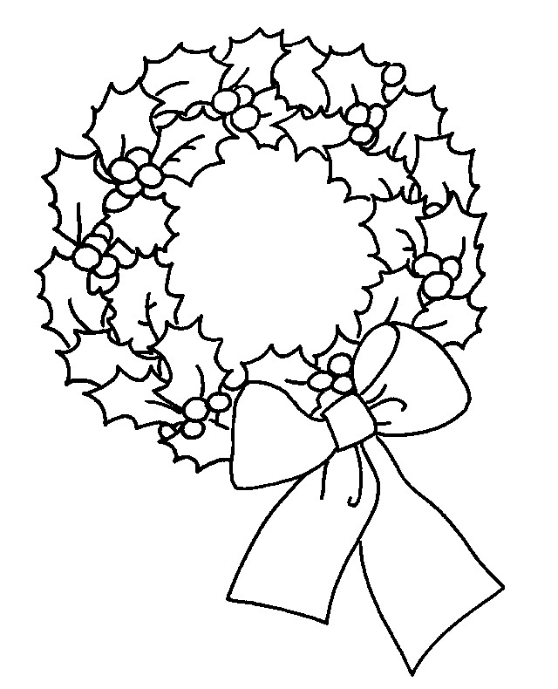

Please join us to make a traditional Holly and Evergreen Wreath. Come and make a wreath that will look beautiful on your front door or as a table centre. This simple but effective design can be decorated in so many different ways to create a truly unique design.

The materials will be provided to make a fresh evergreen wreath adorned with an accent ribbon and dried festive material. Further information about how to personalise your wreath will be sent out to those who book.

The cost of the workshop is £26 which includes Christmas refreshments and a fun festive atmosphere. Total beginners to craft and floristry are very welcome. If you would like to make your design more contemporary this can also be accommodated.

Numbers are limited due to the work space required so please book early for this popular event. Please fill the in the slip below and return it to the blue box by Monday 26th November.

…………………………………………………………………………………………………………………………………………….

Please reserve me ………. places on the Christmas Wreath Workshop @ £26 each.

I enclose a cheque/cash (please circle) for £………………….
(Please make cheques payable to St Peter’s Fundraising)

My preferred colour of ribbon is (please tick)
Natural/Burlap
Silver
Red
Name ………………………………………………………………………………………

Email address…………………………………………………………………………...

Tel……………………………………………………………………………………………...

Further information will be sent out using the details provided above, so an email address is essential. Thanks
No preference
Gold

