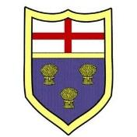
St.Peter’s Church of England Primary School, Heswall
Thurstaston Road, Heswall, Wirral CH60 4SA
Tel: 0151 342 2556 email: schooloffice@stpeters-heswall.wirral.sch.uk
Headteacher: Mr D Jones
www.stpeters-heswall.wirral.sch.uk
firm foundations, shining bright

21st September 2020

Dear Parents/Carers,
We have now been back in school for a few weeks. During this time there has been a great deal of learning across all schools and in the Wirral about procedures in relation to Covid19. I am writing to you to give you an update on these.
You will be aware that from tomorrow, new measures are in place to try and help us combat the rise in cases locally. In addition to these, we would encourage all parents to wear a face covering when dropping children off at school and picking them up. This will help us do everything we can to reduce the spread from adult to adult.
Here are reminders of what to do in a variety of situations:

What to do if my child has symptoms What to do if someone in the house has
symptoms

When to get a test

What if my child tests positive What if someone in the house tests positive

When will schools close
It is very unlikely that a school will close. If there is a positive test result for a member of staff or a pupil, that class and staff or pupils who have been in close contact with the person 48 hours prior to symptoms starting will be sent home to self-isolate. There is no advantage to getting a test within this time period as even with a negative test, everyone identified as a close contact must still isolate for the full 14 days. Only get a test for your child if they develop one of the three key symptoms.
Public Health will advise schools when they need to make these decisions on an individual basis.

What about learning if the school is closed
If a child is absent from school in relation to Covid19 (e.g. because they have symptoms, because someone in their household has symptoms, because their class is closed) children will be provided with home learning.
Please see the link below to access our Remote Educational Plan in the event of a class, group or a small number of pupils needing to self-isolate. Our Remote Educational Plan can be downloaded to our school website, please click on the link below.
Remote Educational Plan Link –

Thank you for your continued support.
Yours sincerely,
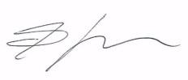
Darren Jones
Headteacher

