St. Peter’s CE Primary School, Heswall
Parent Code of Conduct
ST. PETER’S CE PRIMARY SCHOOL
firm foundations, shining bright
John 8:12 “I am the light of the world. Whoever follows me will never walk in darkness, but will have the light of life.”

Matthew 16:18 “You are Peter and upon this rock I shall build my church.”

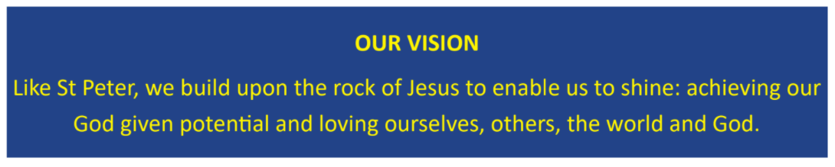

2021 – 2022

PARENT CODE OF CONDUCT
Contents
- Purpose and scope
- Our expectations of parents and carers
- Behaviour that will not be tolerated
- Breaching the code of conduct

Number 1

Purpose and scope
At St. Peter’s CE Primary School, we believe it is important to:
  - Work in partnership with parents to support their child’s learning
  - Create a safe, respectful and inclusive environment for pupils, staff and parents
  - Model appropriate behaviour for our pupils at all times
To help us do this, we set clear expectations and guidelines on behaviour for all members of our community. This includes staff (through the Staff Code of Conduct policy) and pupils (through our Behaviour policy).
This code of conduct aims to help the school work together with parents by setting guidelines on appropriate behaviour.
We use the term ‘parents’ to refer to:
  - Anyone with parental responsibility for a pupil
  - Anyone caring for a child (such as grandparents or child-minders)

Number 2

Our expectations of parents and carers
We expect parents, carers and other visitors to:
  - Respect the ethos, vision and values of our school
  - Work together with staff in the best interests of our pupils
  - Treat all members of the school community with respect – setting a good example with speech and behaviour
  - Seek a peaceful solution to all issues
  - Correct their own child’s behaviour (or those in their care), particularly in public, where it could lead to conflict, aggression or unsafe conduct
  - Approach the right member of school staff to help resolve any issues of concern

Number 3

Behaviour that will not be tolerated
  - Disrupting, or threatening to disrupt, school operations (including events on the school grounds and sports team matches)
  - Swearing, or using offensive language
  - Displaying a temper, or shouting at members of staff, pupils or other parents
  - Threatening another member of the school community
  - Sending abusive messages to another member of the school community, including via text, email or social media
  - Posting defamatory, offensive or derogatory comments about the school, its staff or any member of its community, on social media platforms
  - Use of physical punishment against your child while on school premises
  - Any aggressive behaviour (including verbally or in writing) towards another child or adult
  - Disciplining another person’s child – please bring any behaviour incidents to a member of staff’s attention
  - Smoking or drinking alcohol on the school premises (unless alcohol has been allowed at a specific event)
  - Possessing or taking drugs (including legal highs)

Number 4

Breaching the code of conduct
If the school suspects, or becomes aware, that a parent has breached the code of conduct, the school will gather information from those involved and contact the parent about the incident.

Depending on the nature of the incident, the school may then:
  - Send a warning letter to the parent
  - Invite the parent in to school to meet with a senior member of staff or the headteacher
  - Invite the parent in to school to meet with the Chair of Governors and the headteacher. Further action may need to be taken which is deemed necessary by the Chair of Governors and the headteacher
  - Contact the appropriate authorities (in cases of criminal behaviour)
  - Seek advice from our legal advisors regarding further action (in cases of conduct that may be libellous or slanderous)

The school will always respond to an incident in a proportional way. The final decision for how to respond to breaches of the code of conduct rests with the headteacher.

